**Music School Management**

Hung Wan En (37542923)

– Screenshot –

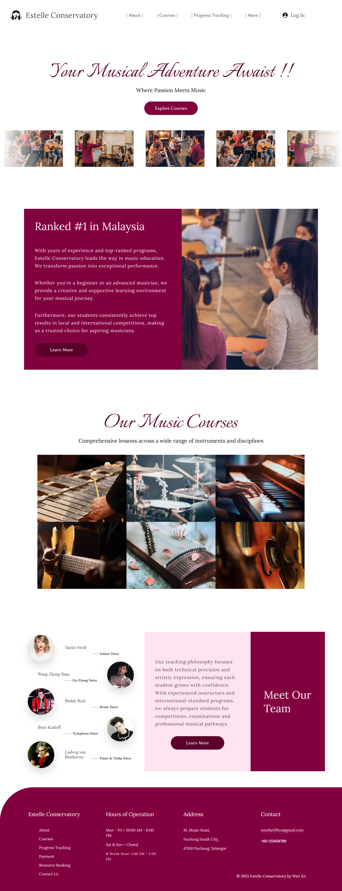

Homepage:



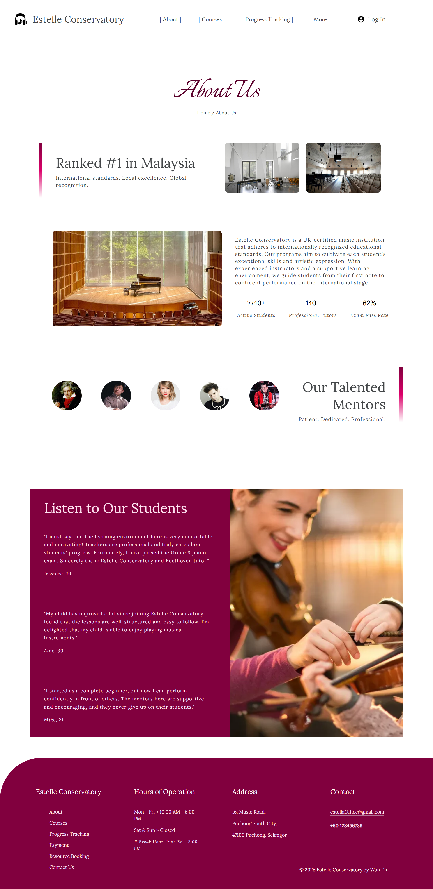

About:











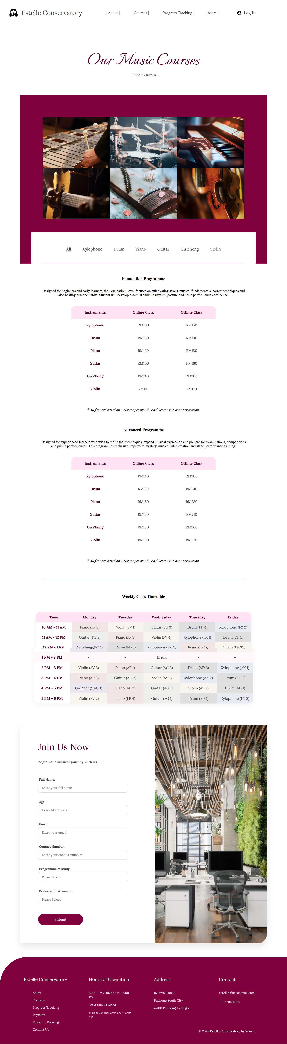

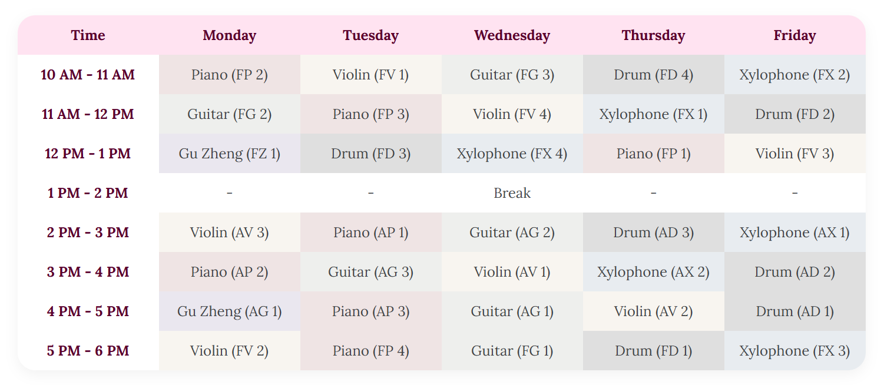

Courses:



Course:



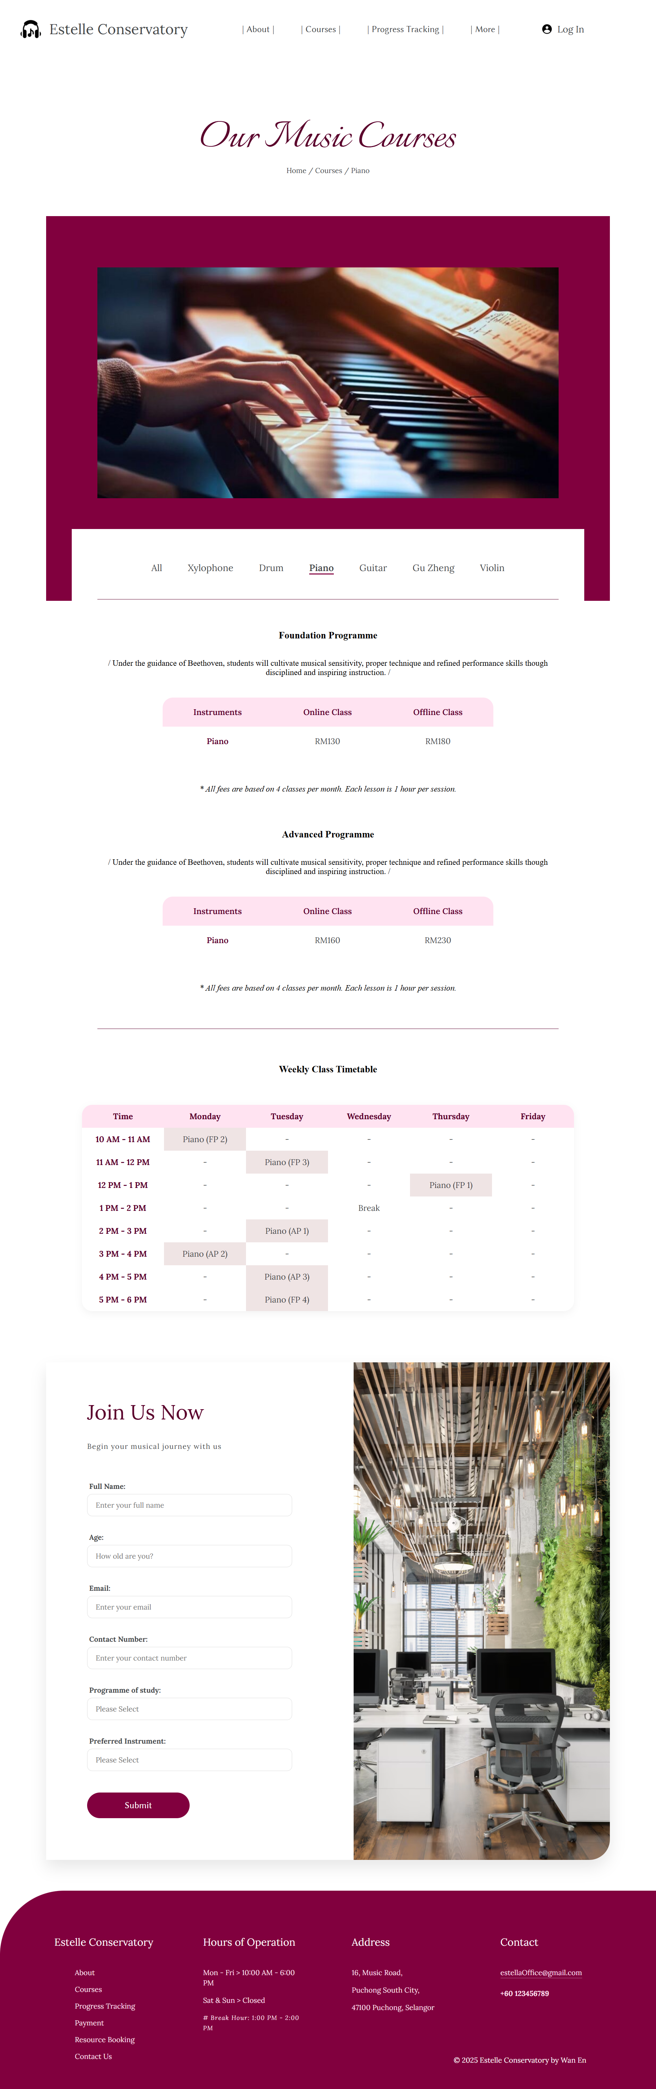

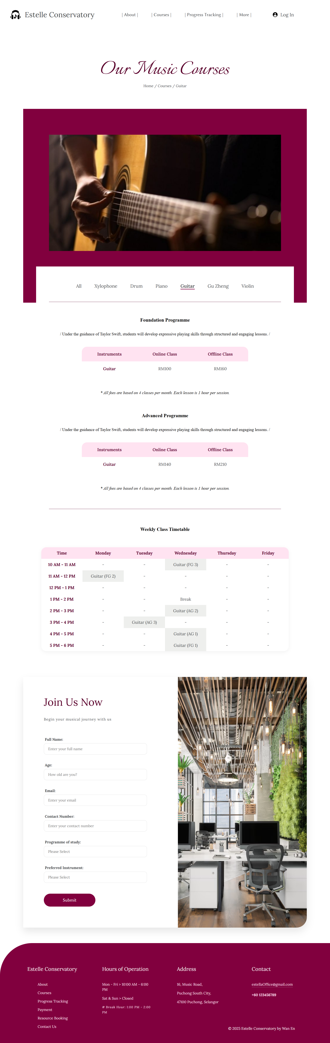

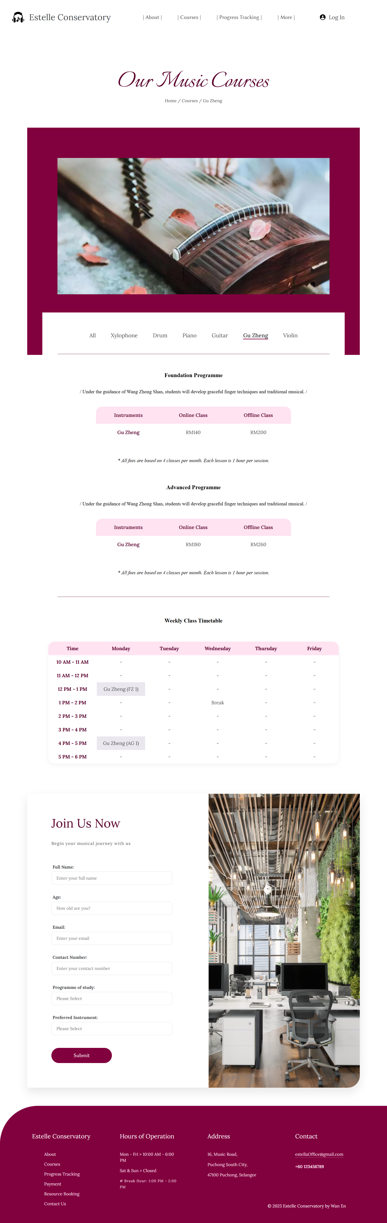



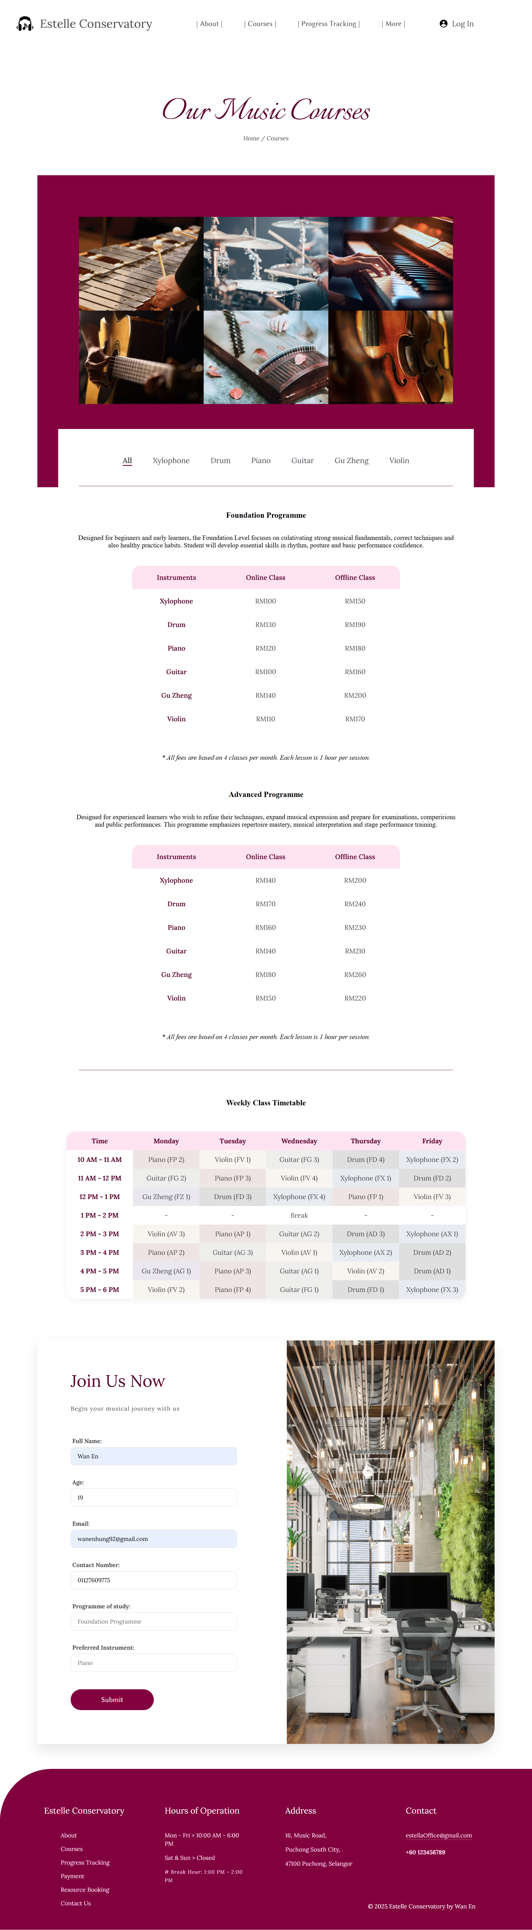

Form:

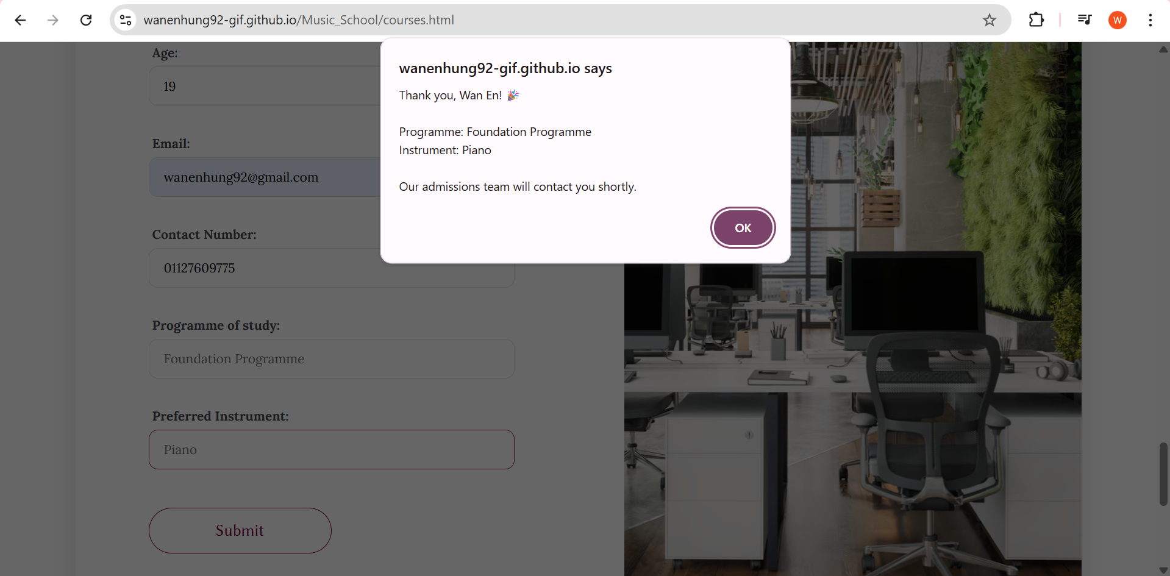

Progress Tracking:

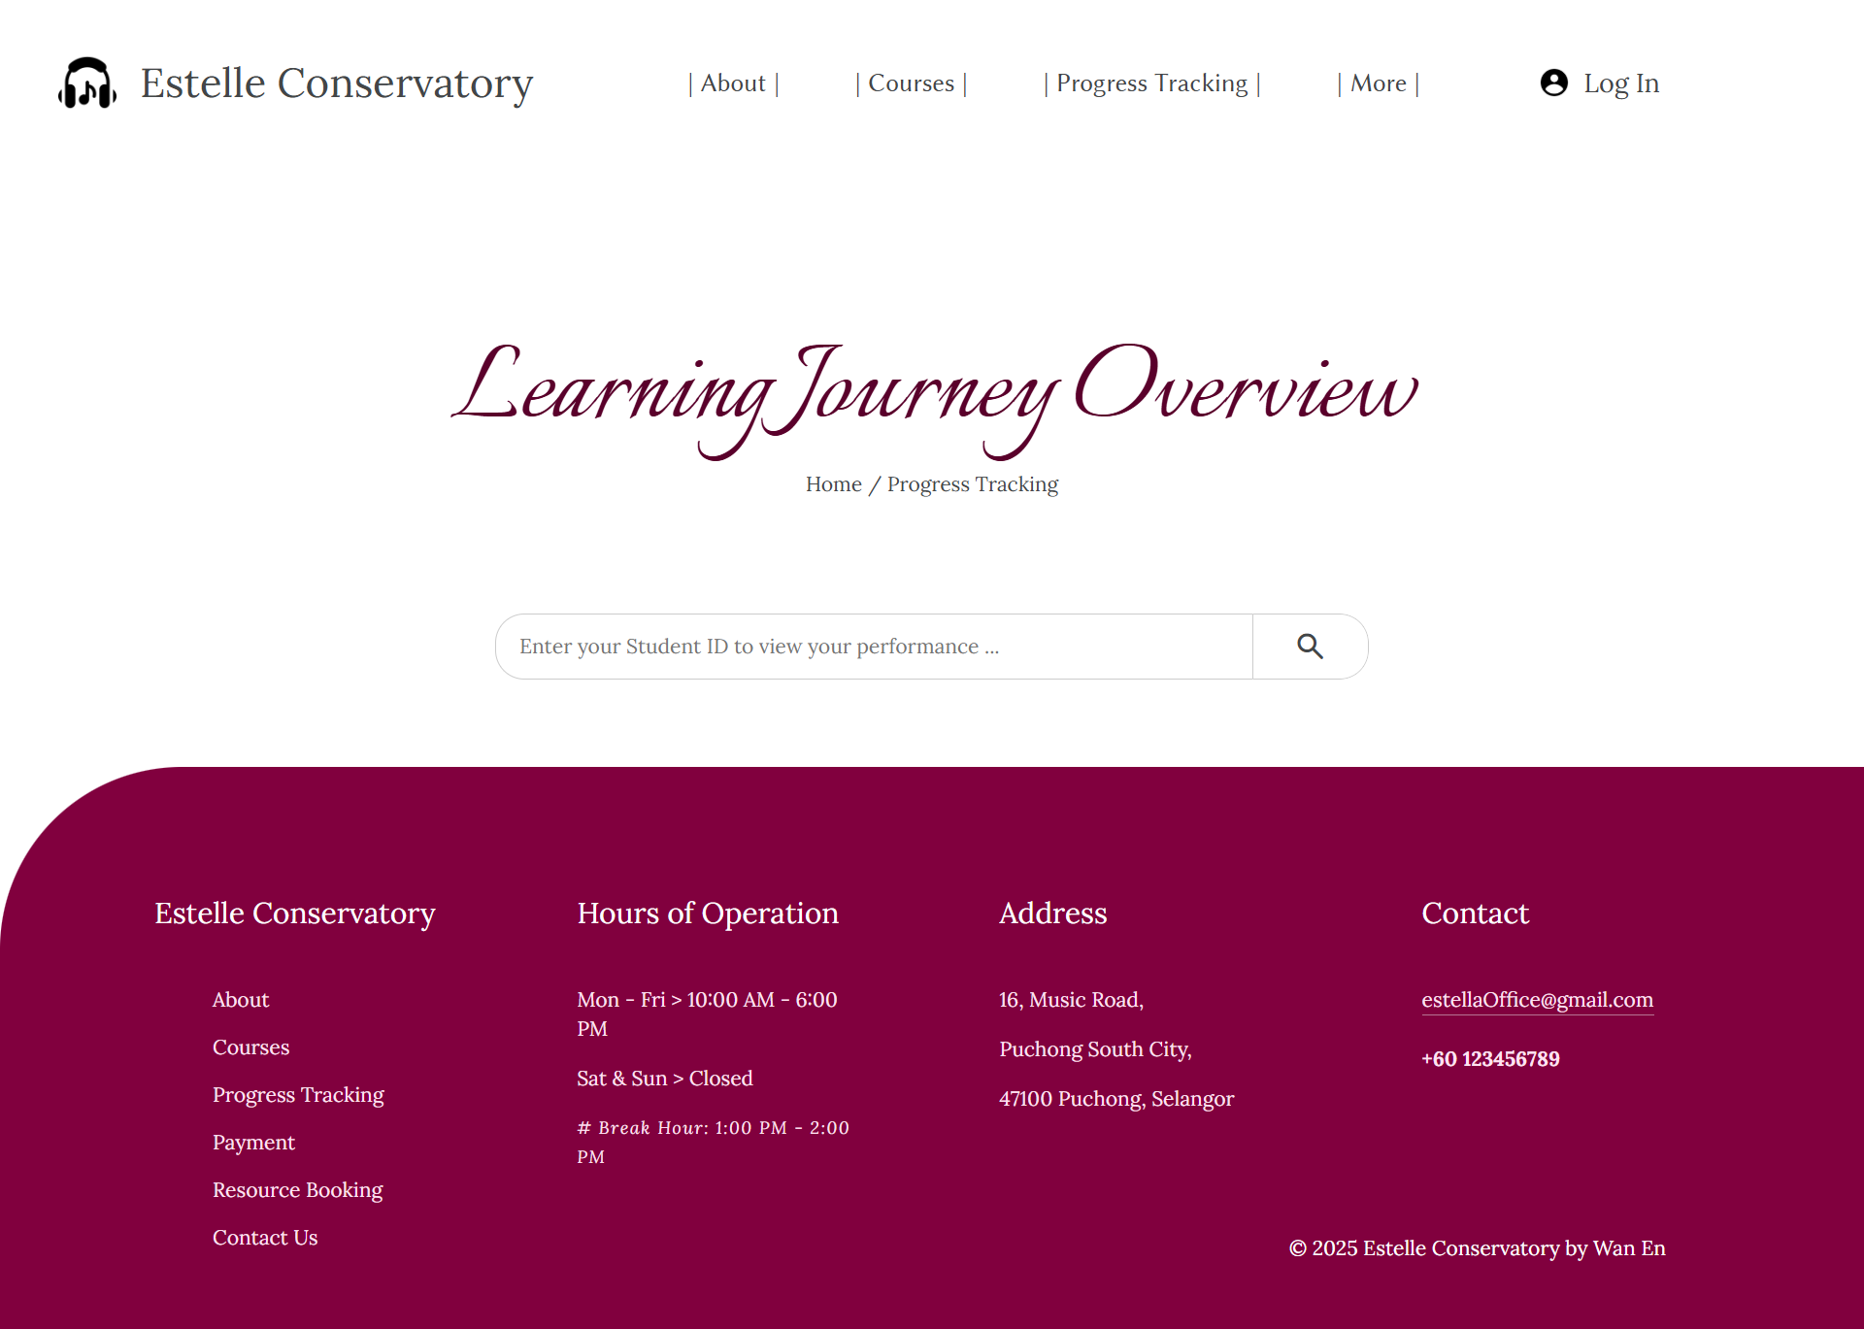

* Students in Estelle Conservatory:

Wan En (37542923)

Jack (38292917)

Emily Tan (37542929)

Ryan Lee (38524930)

Mei Ling (37542931)

Hafiz Amir (38325429)

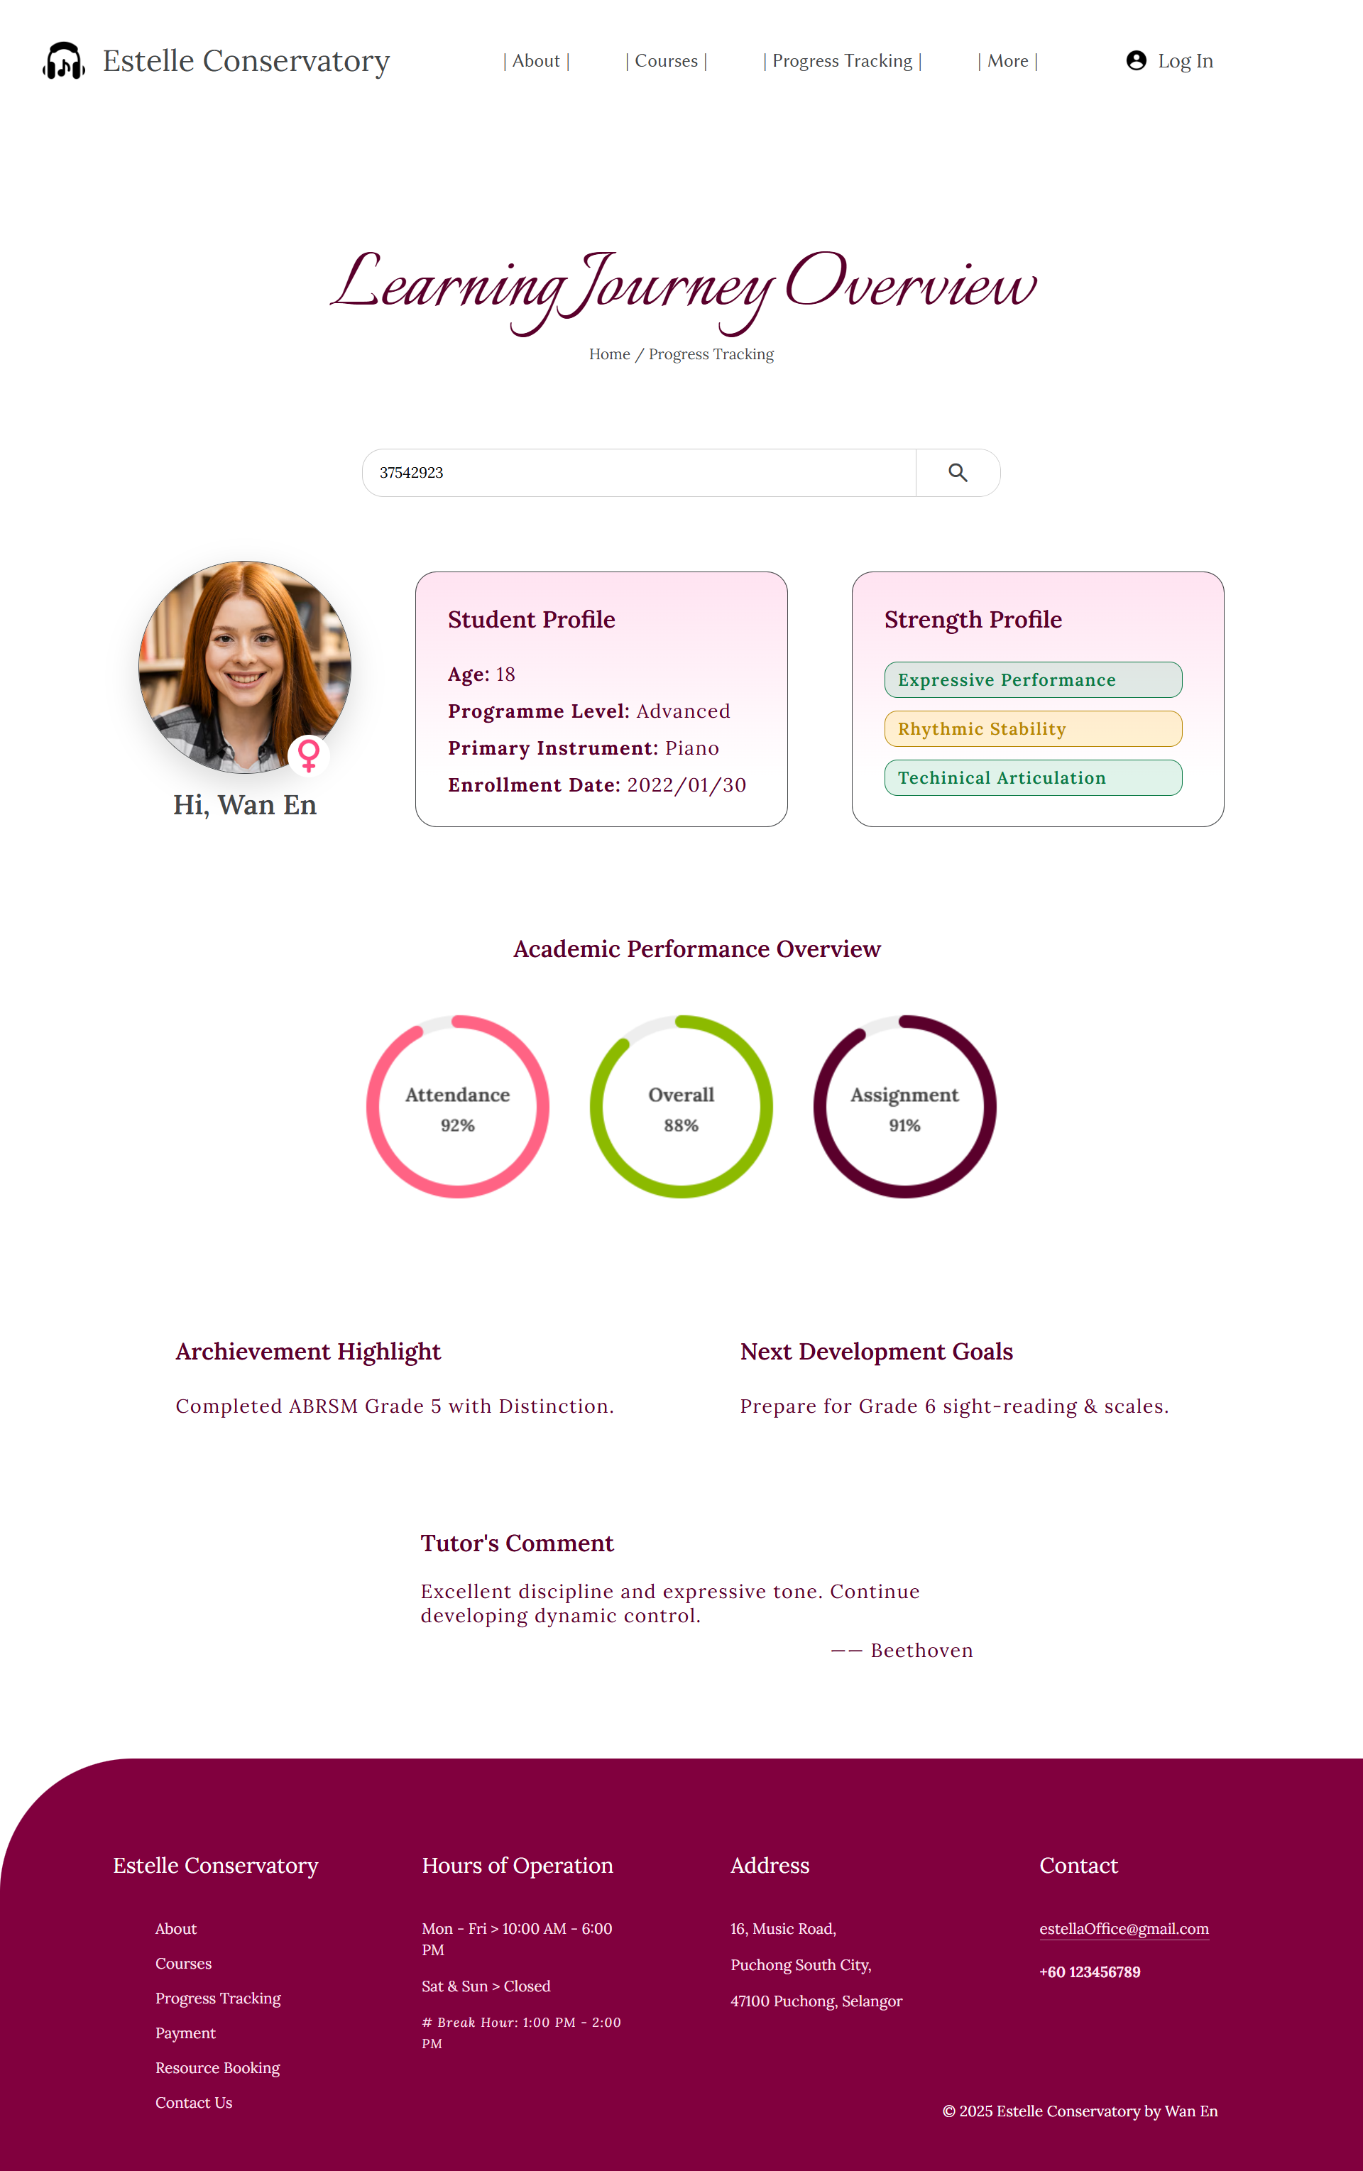

Payment:

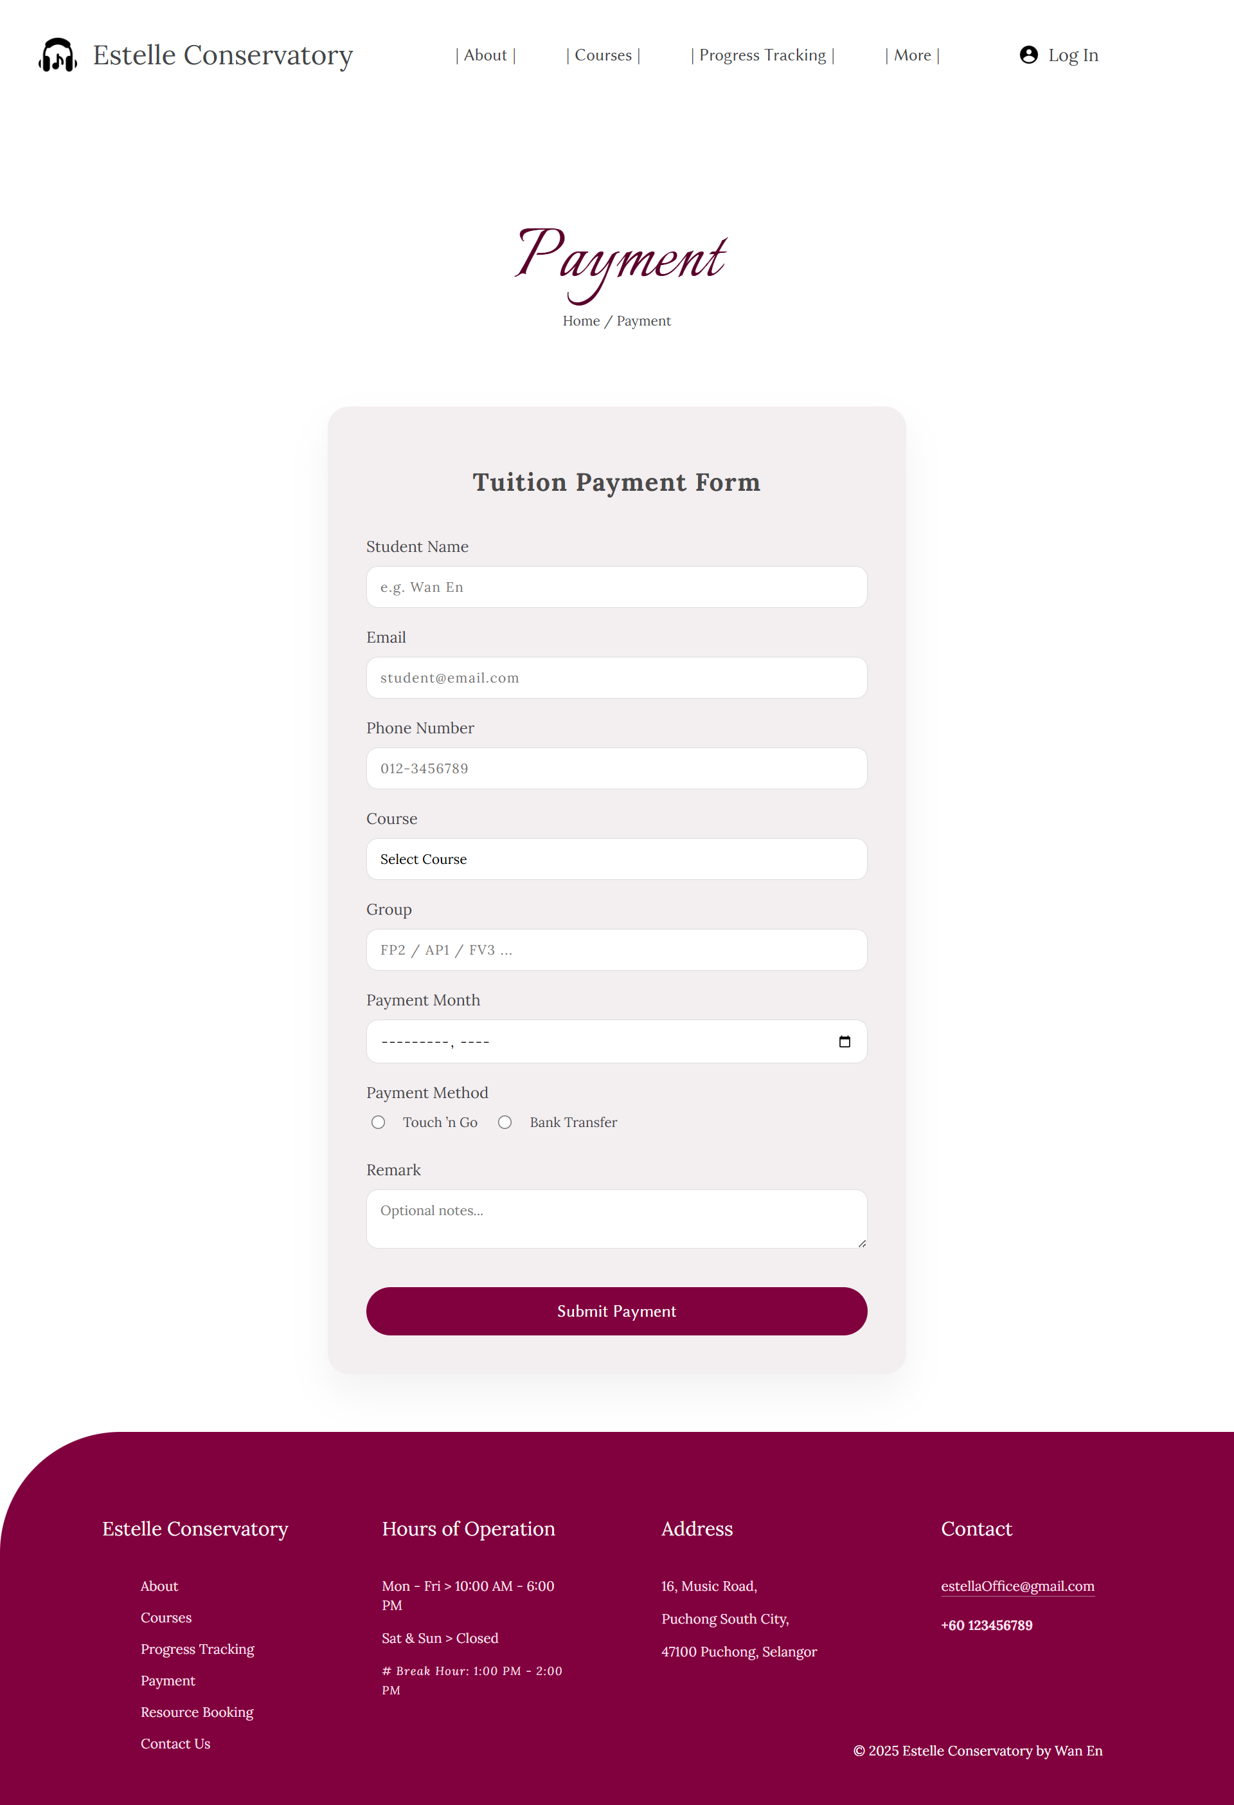

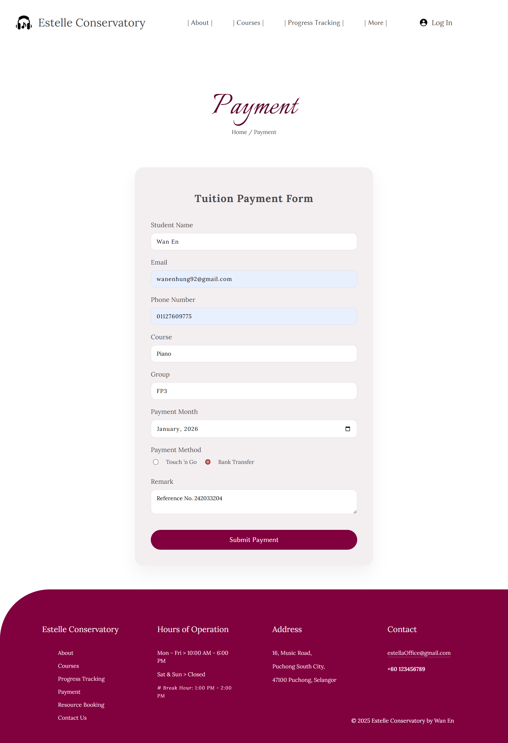

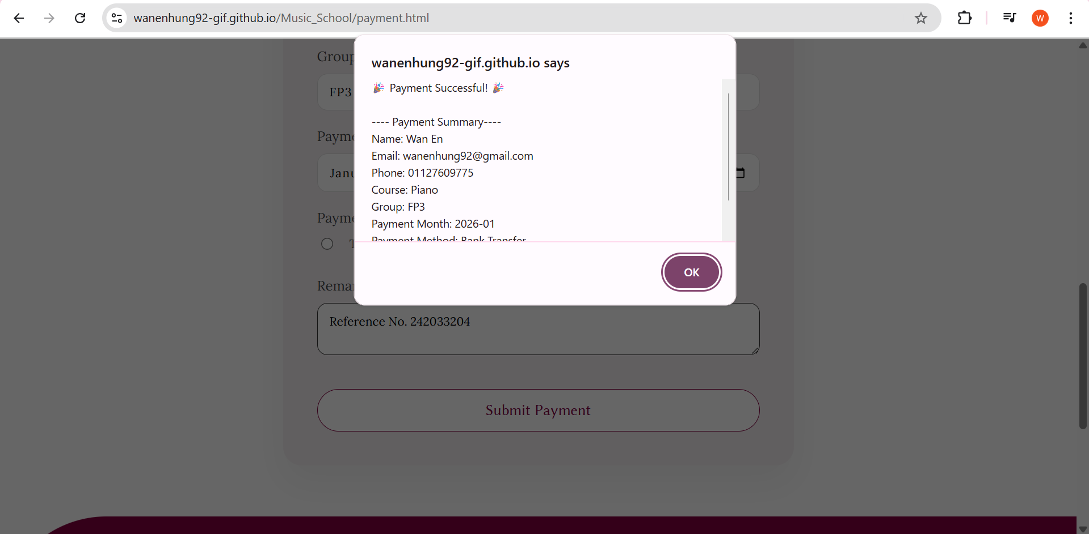

Resource Booking:

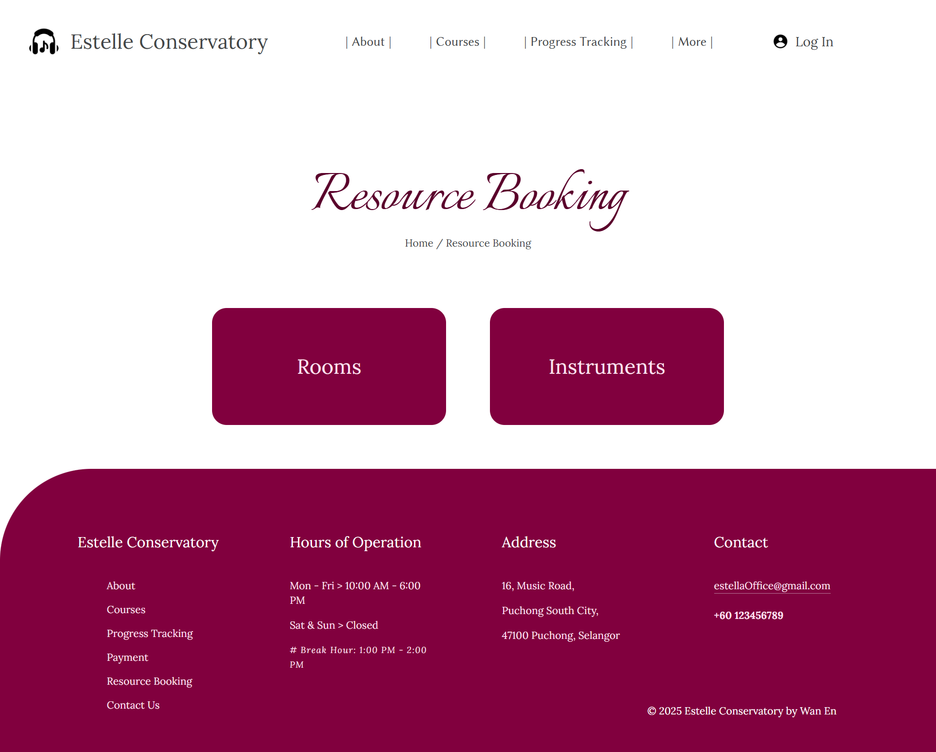

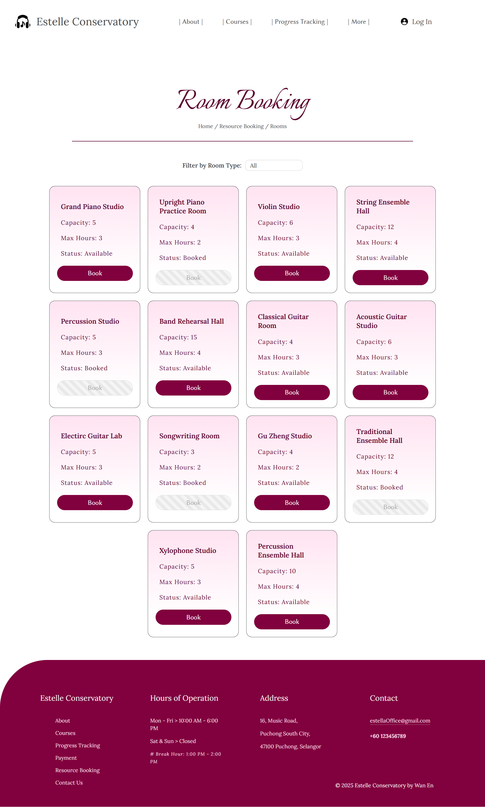

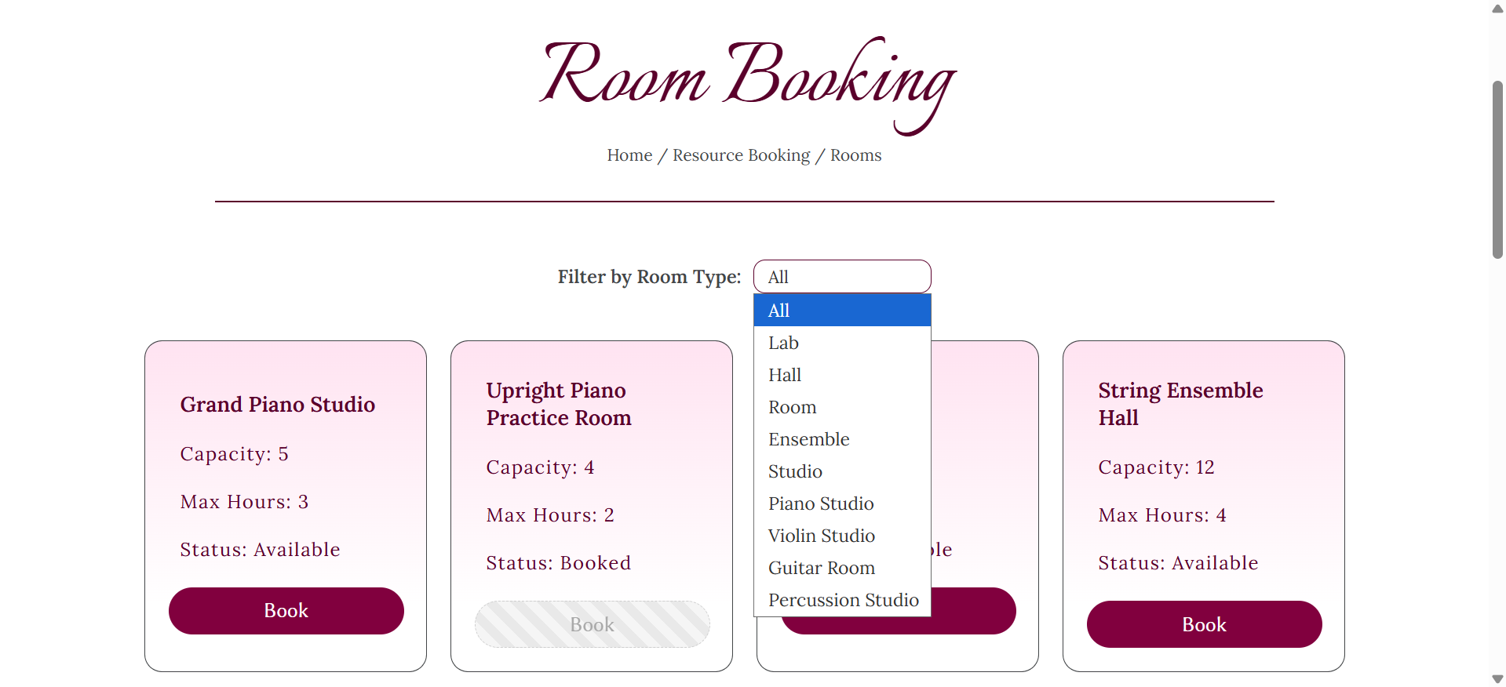

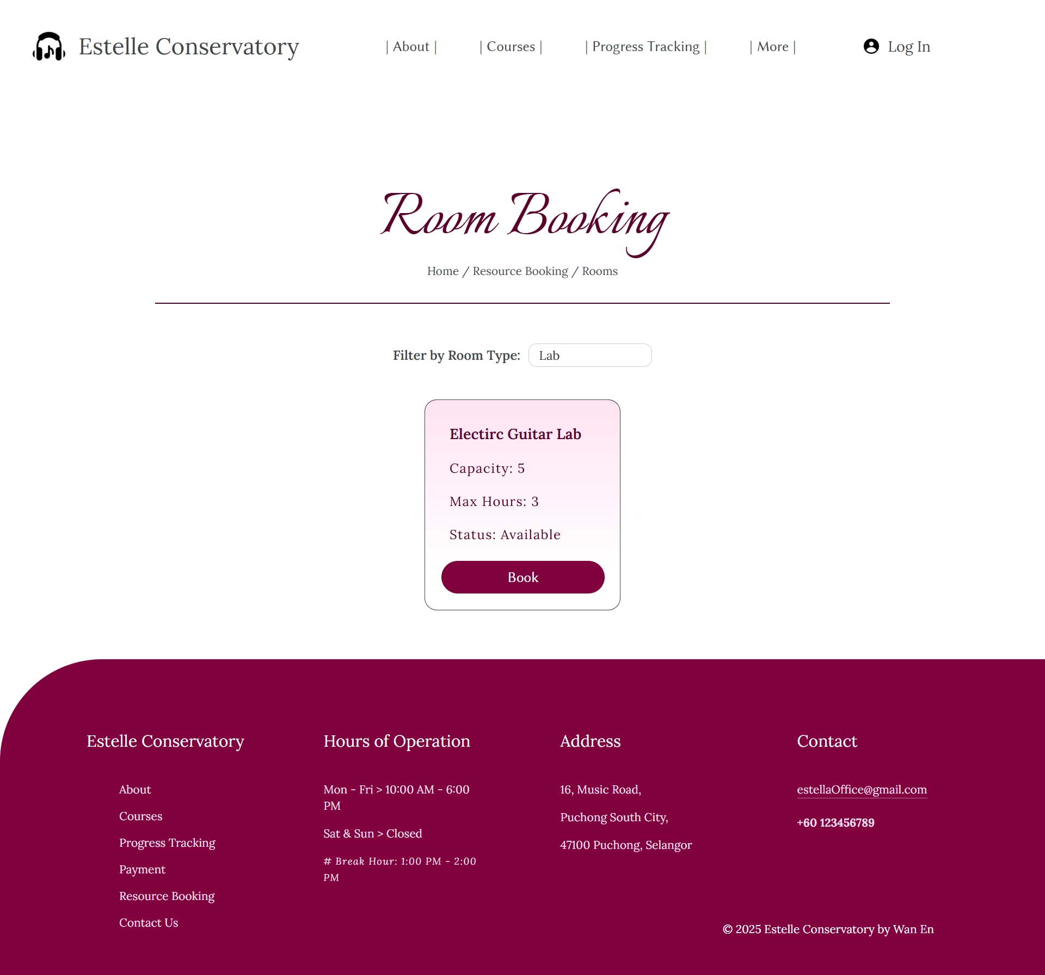

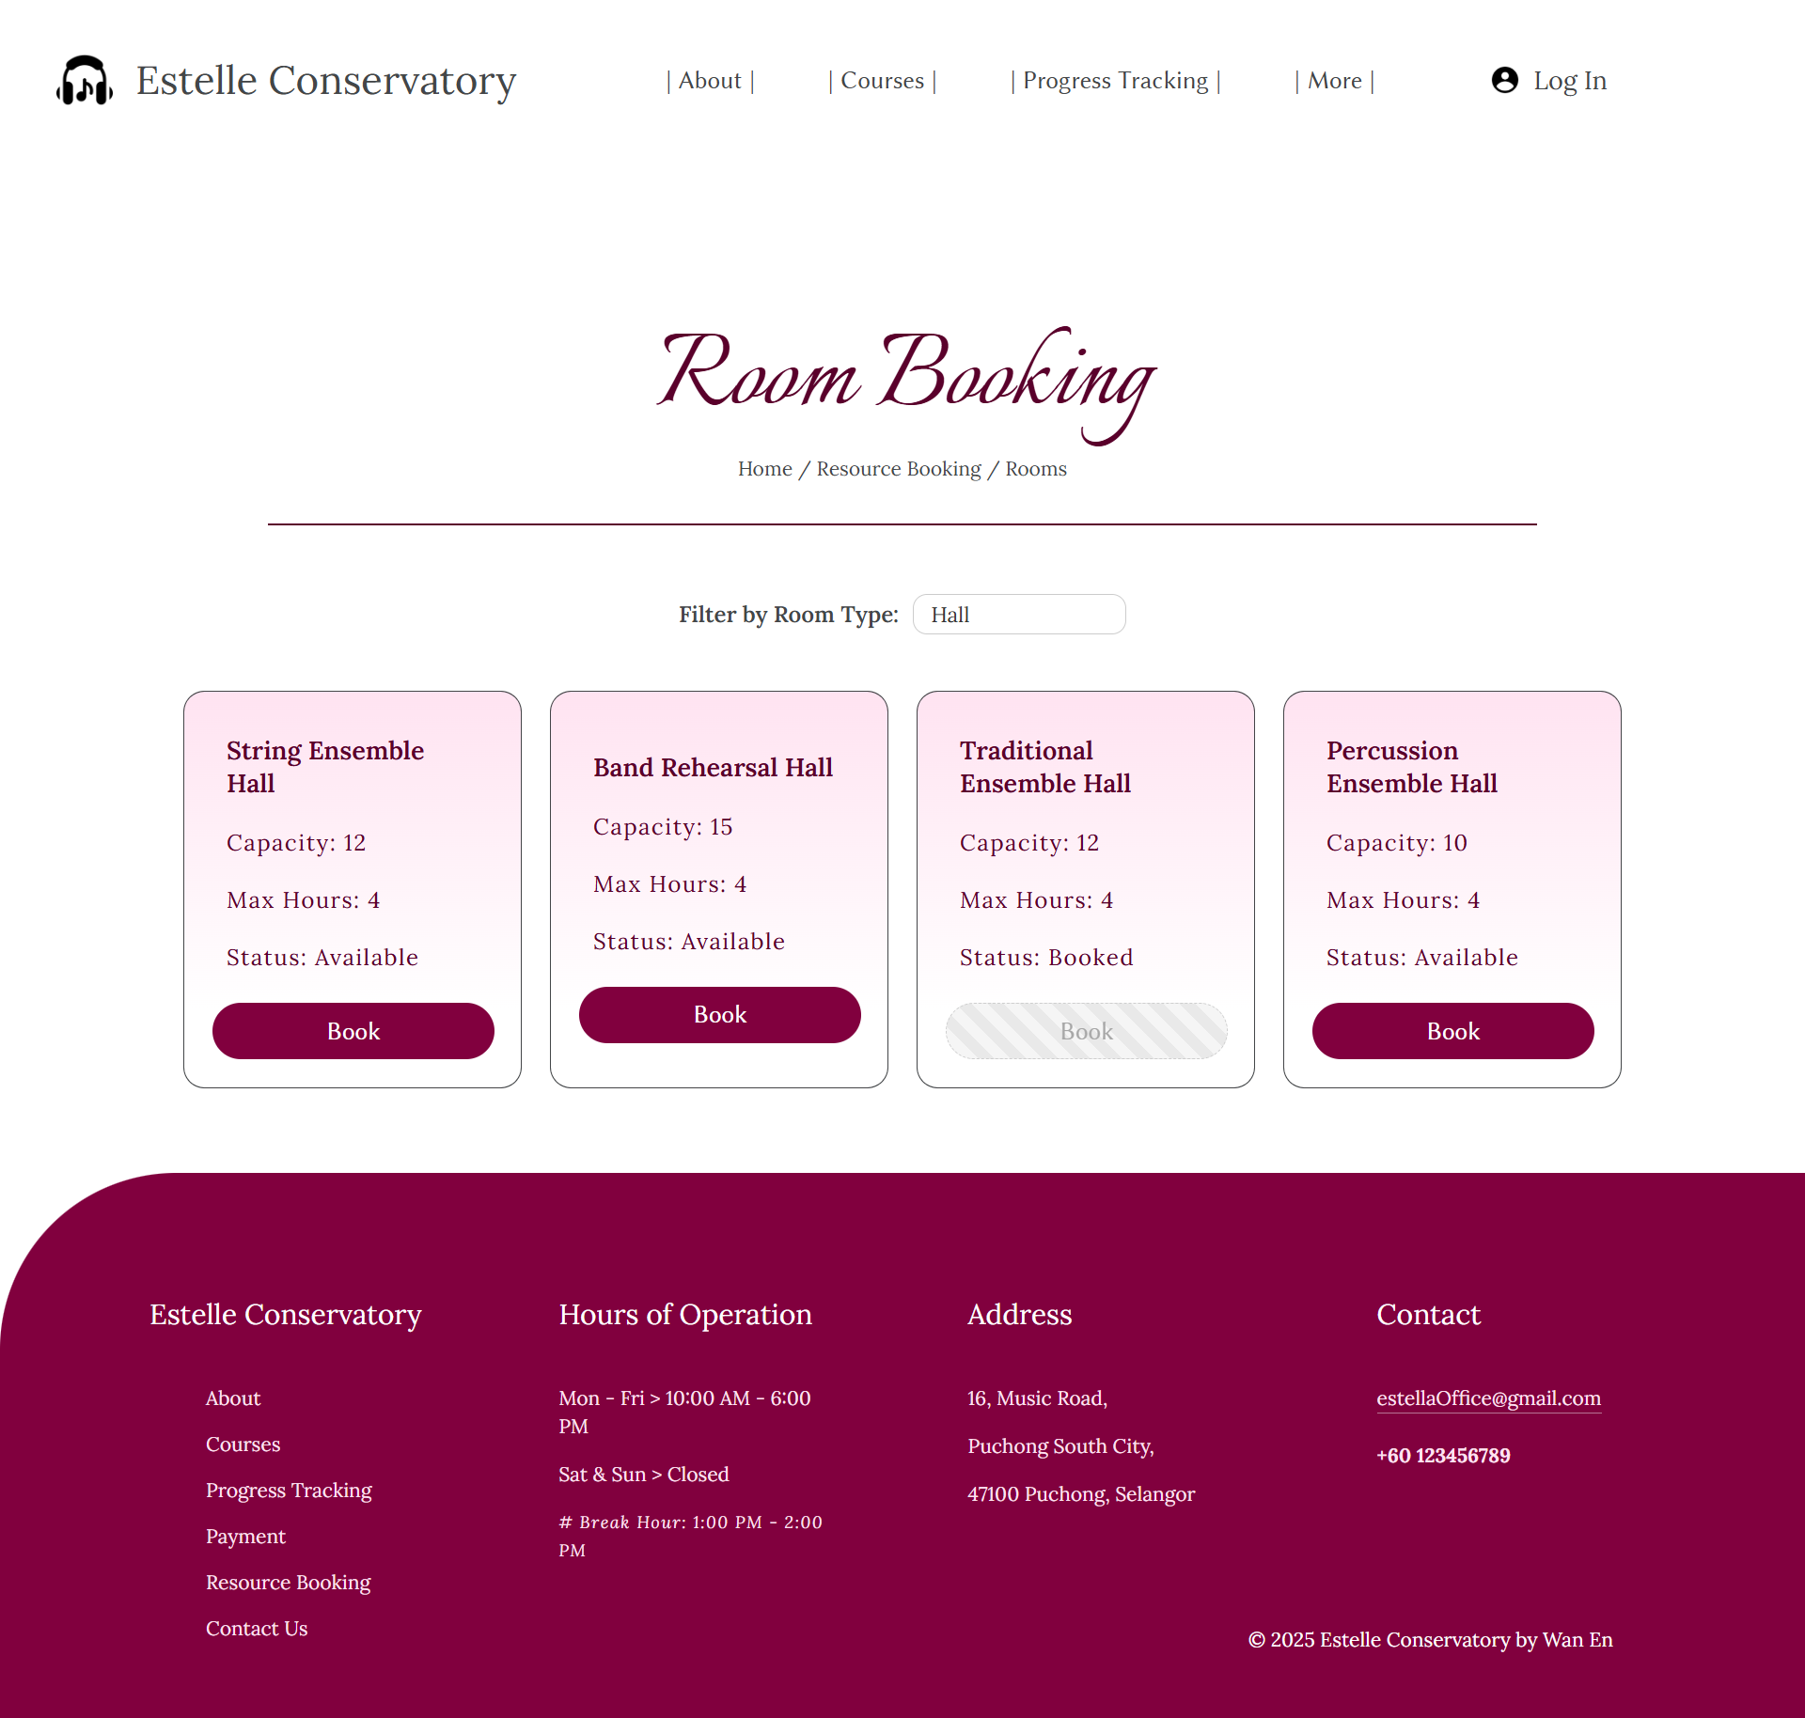

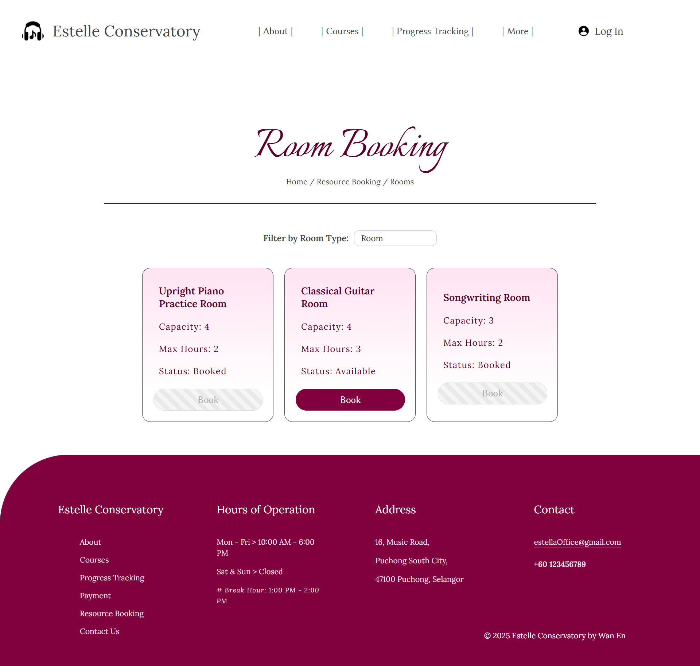

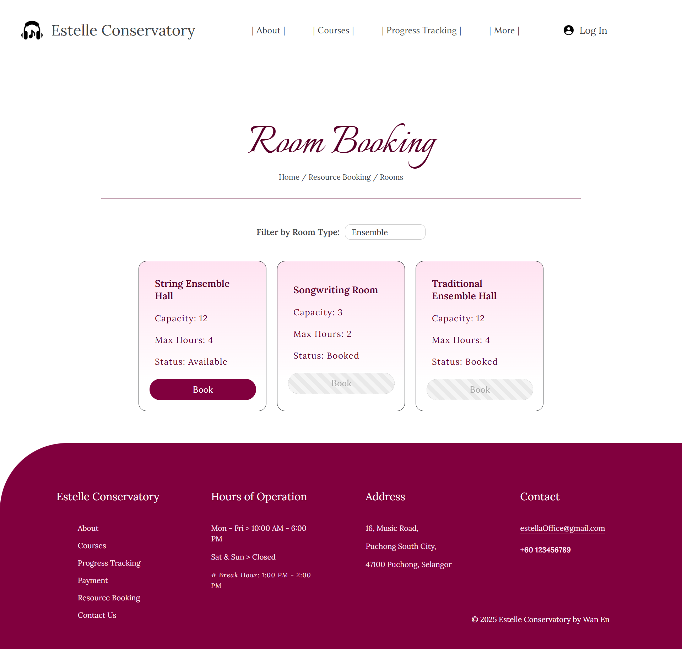

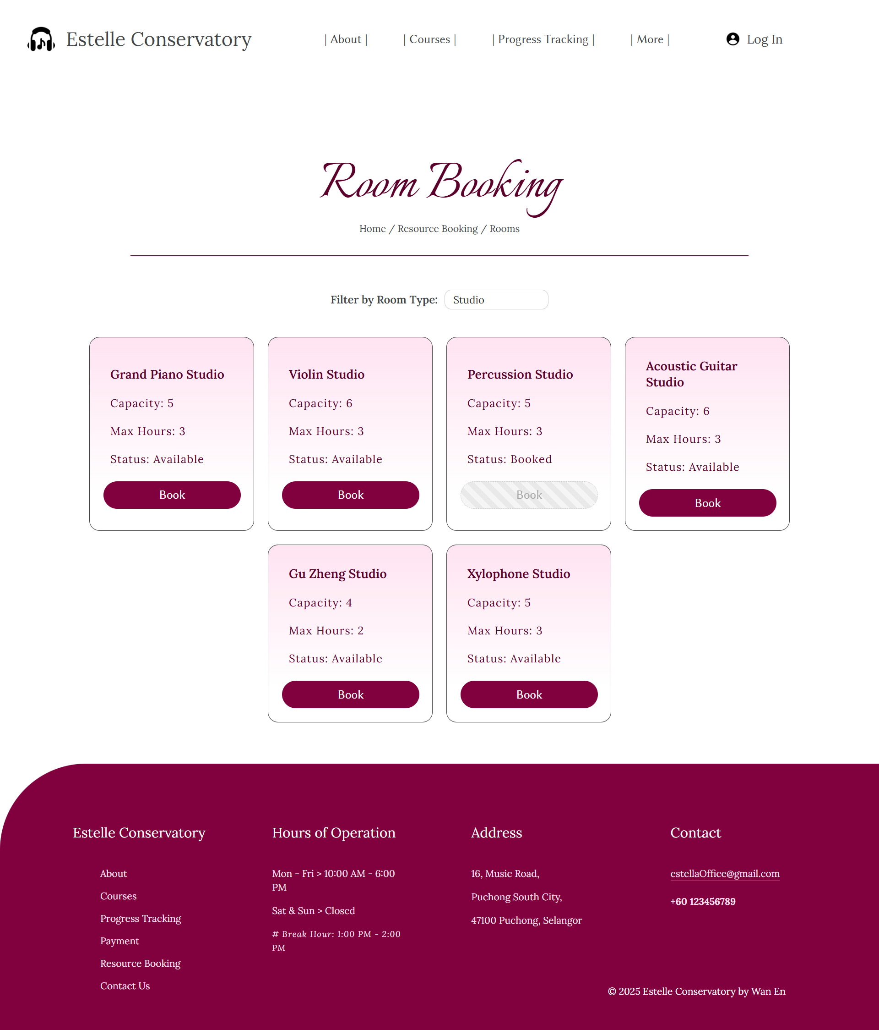

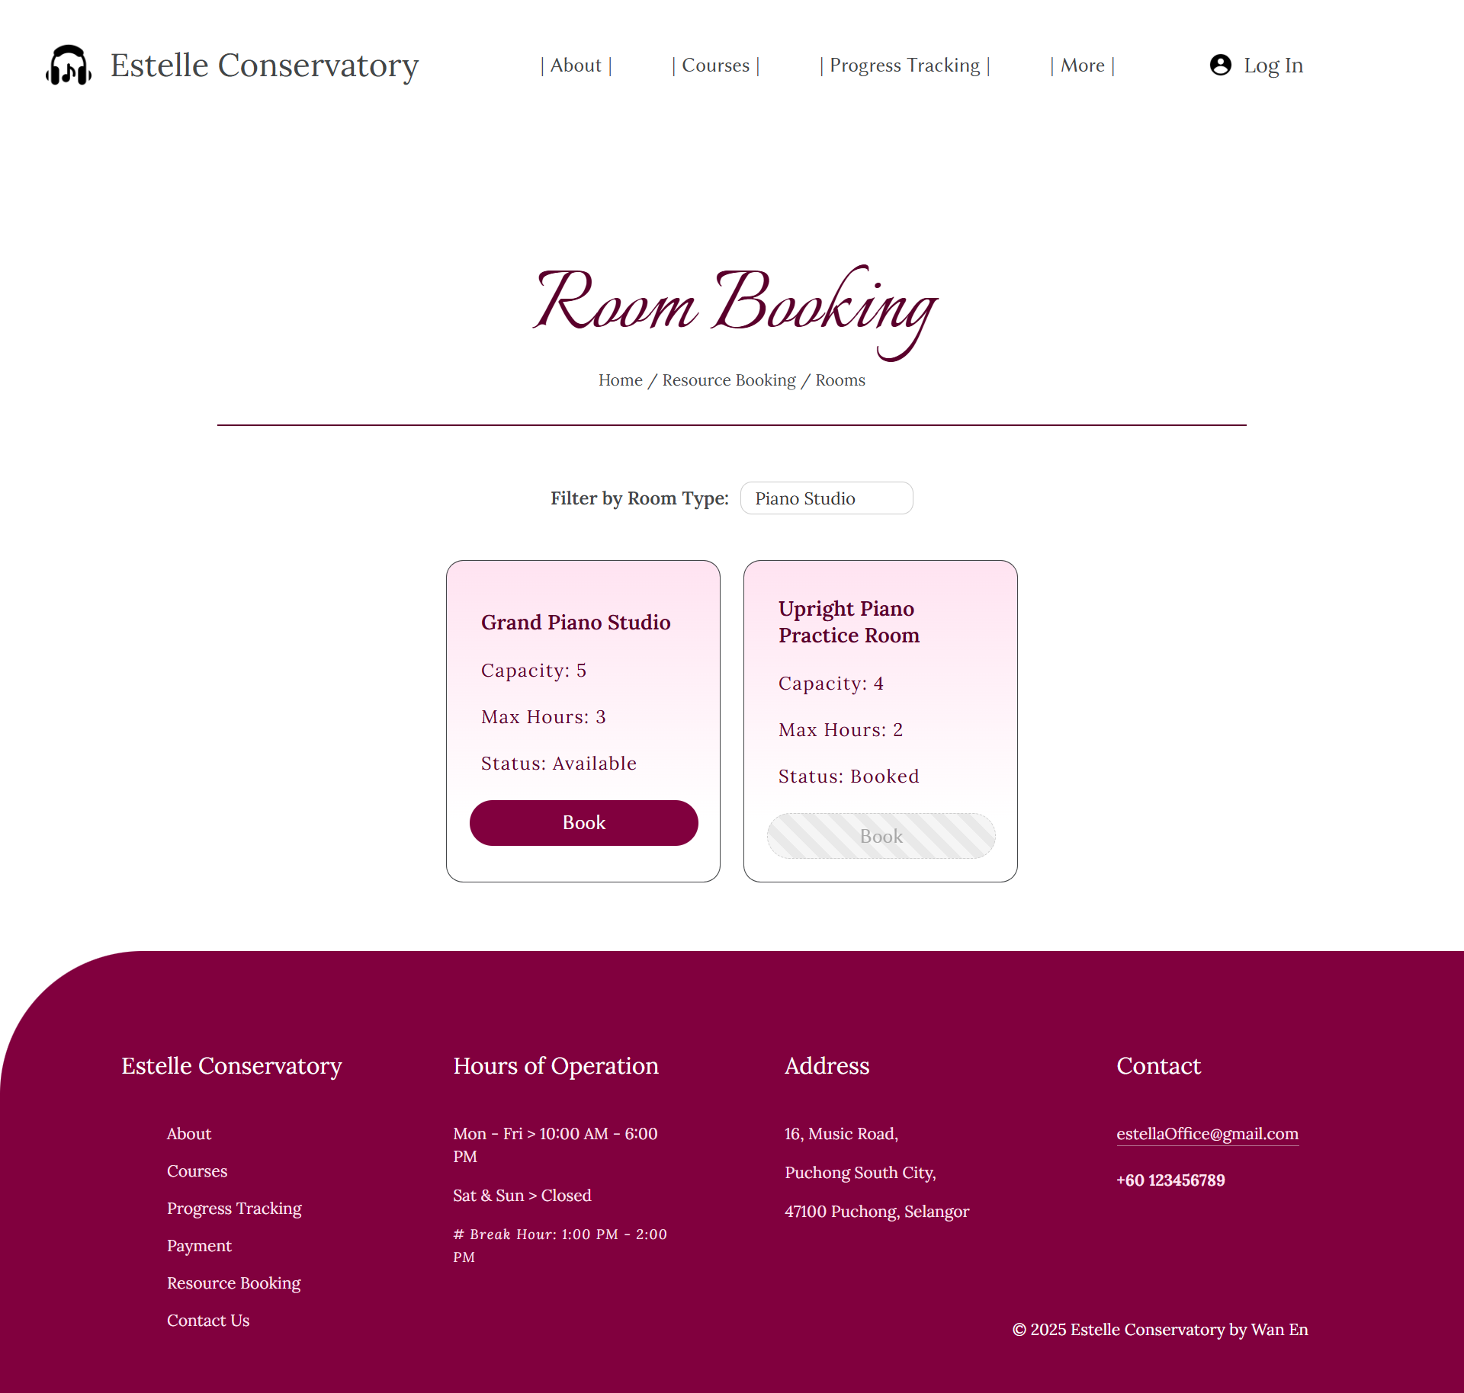

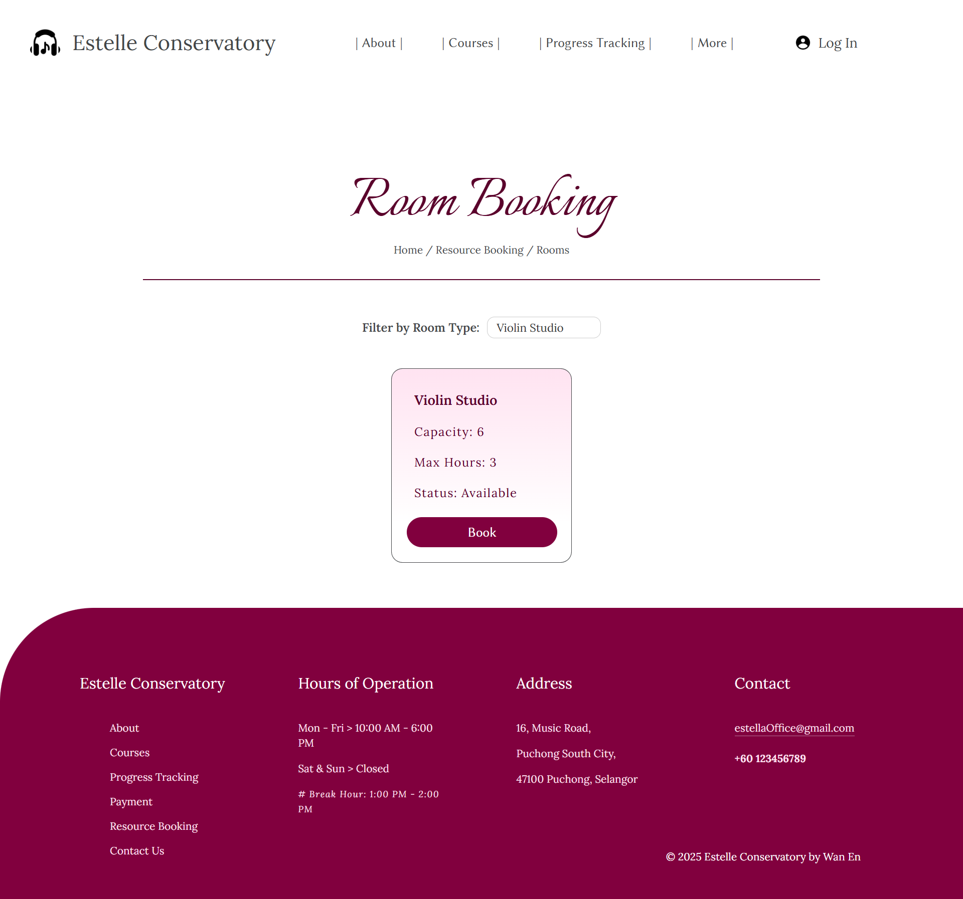

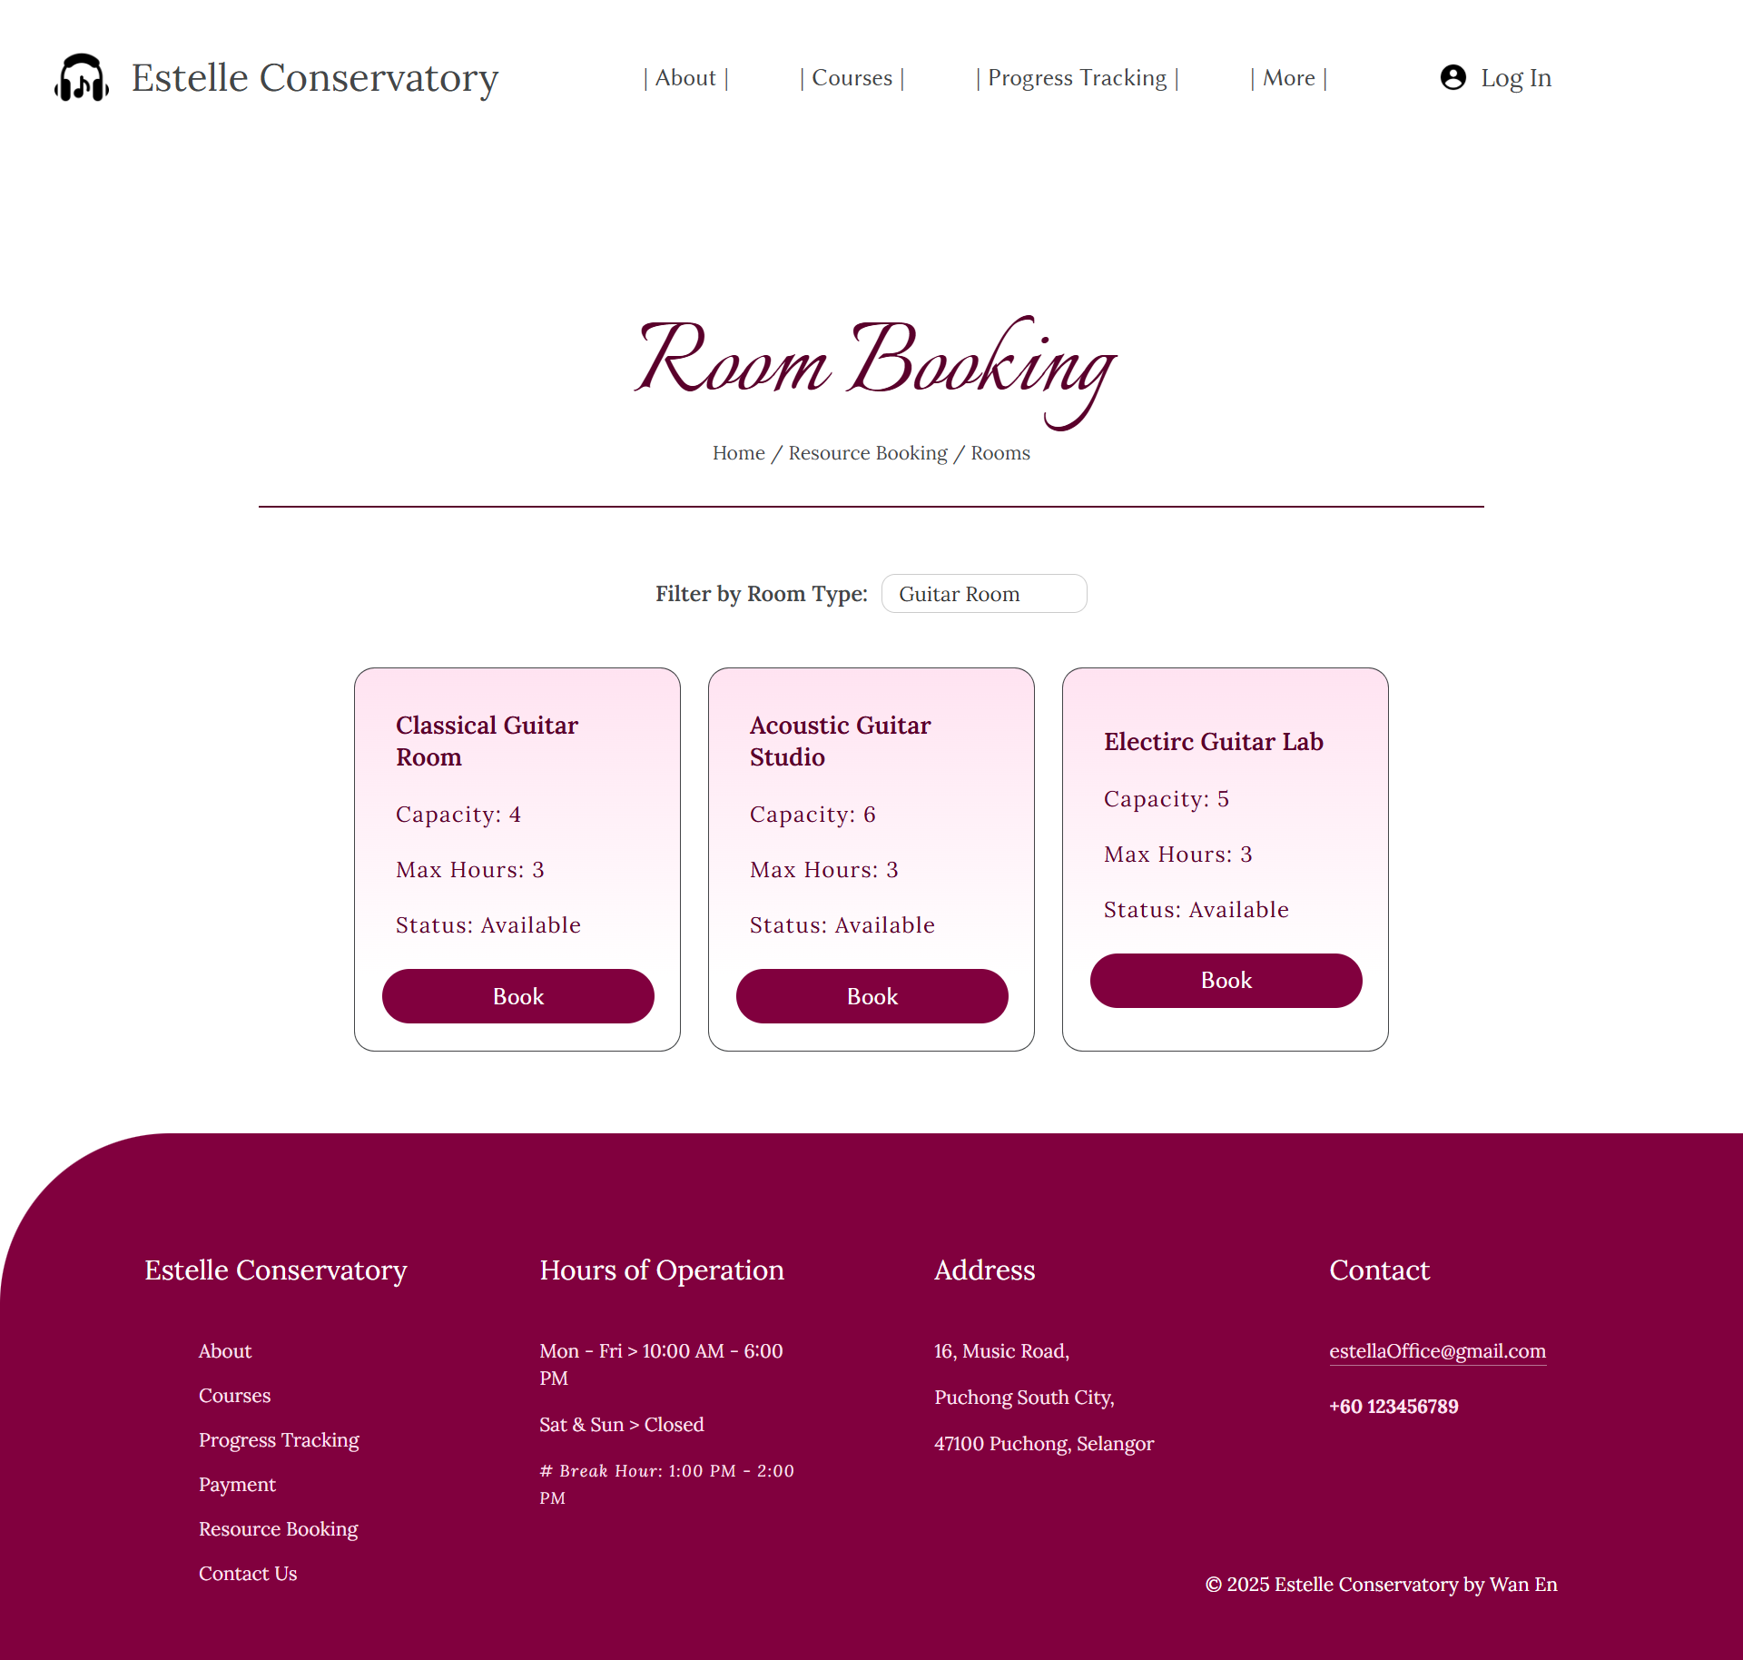

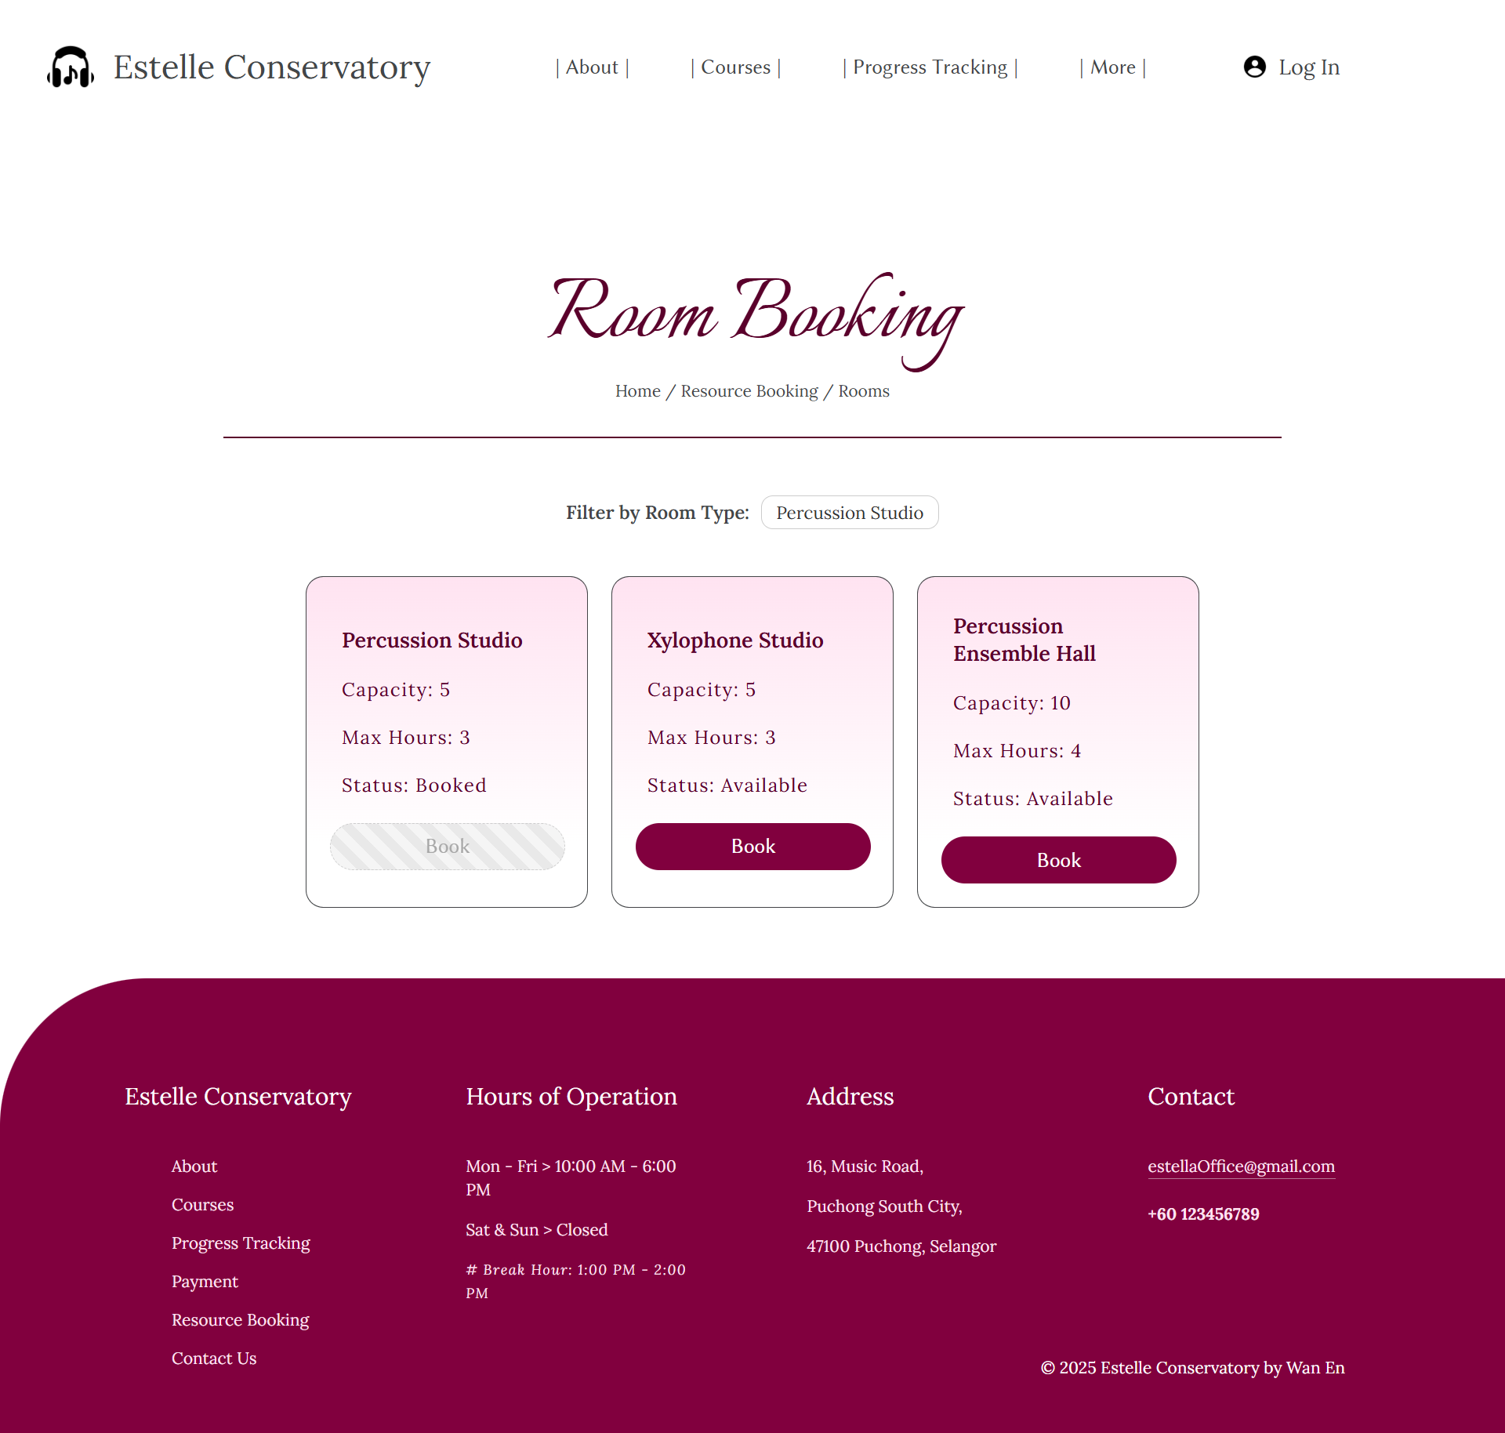

Booking Form:

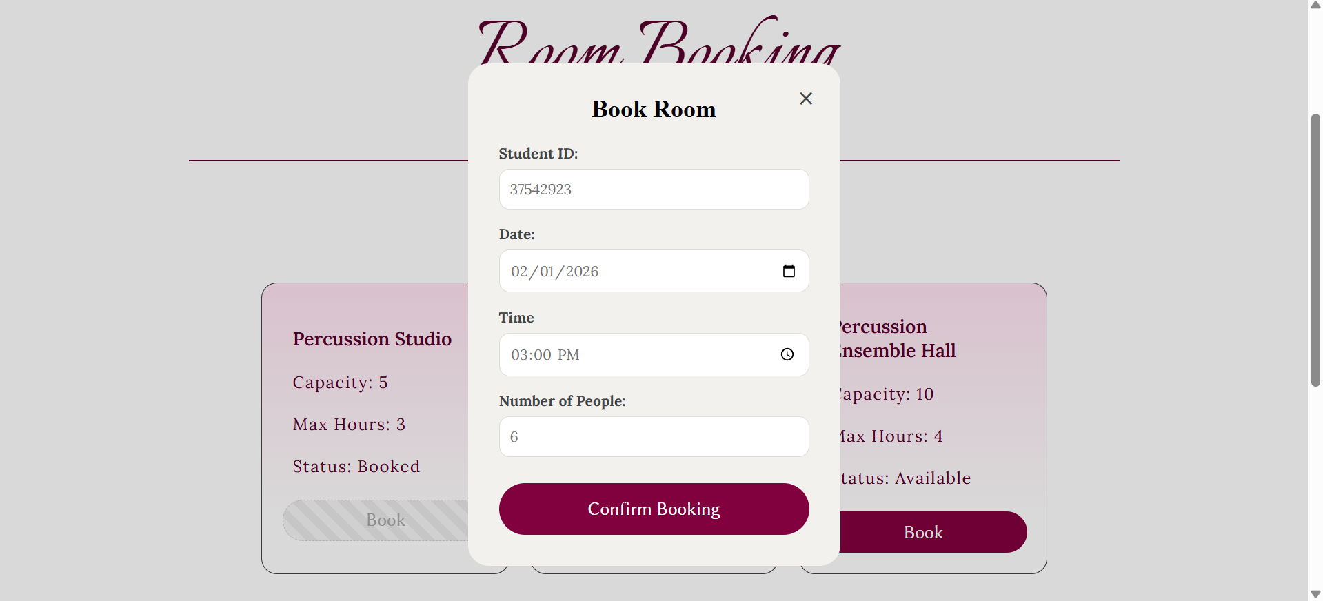

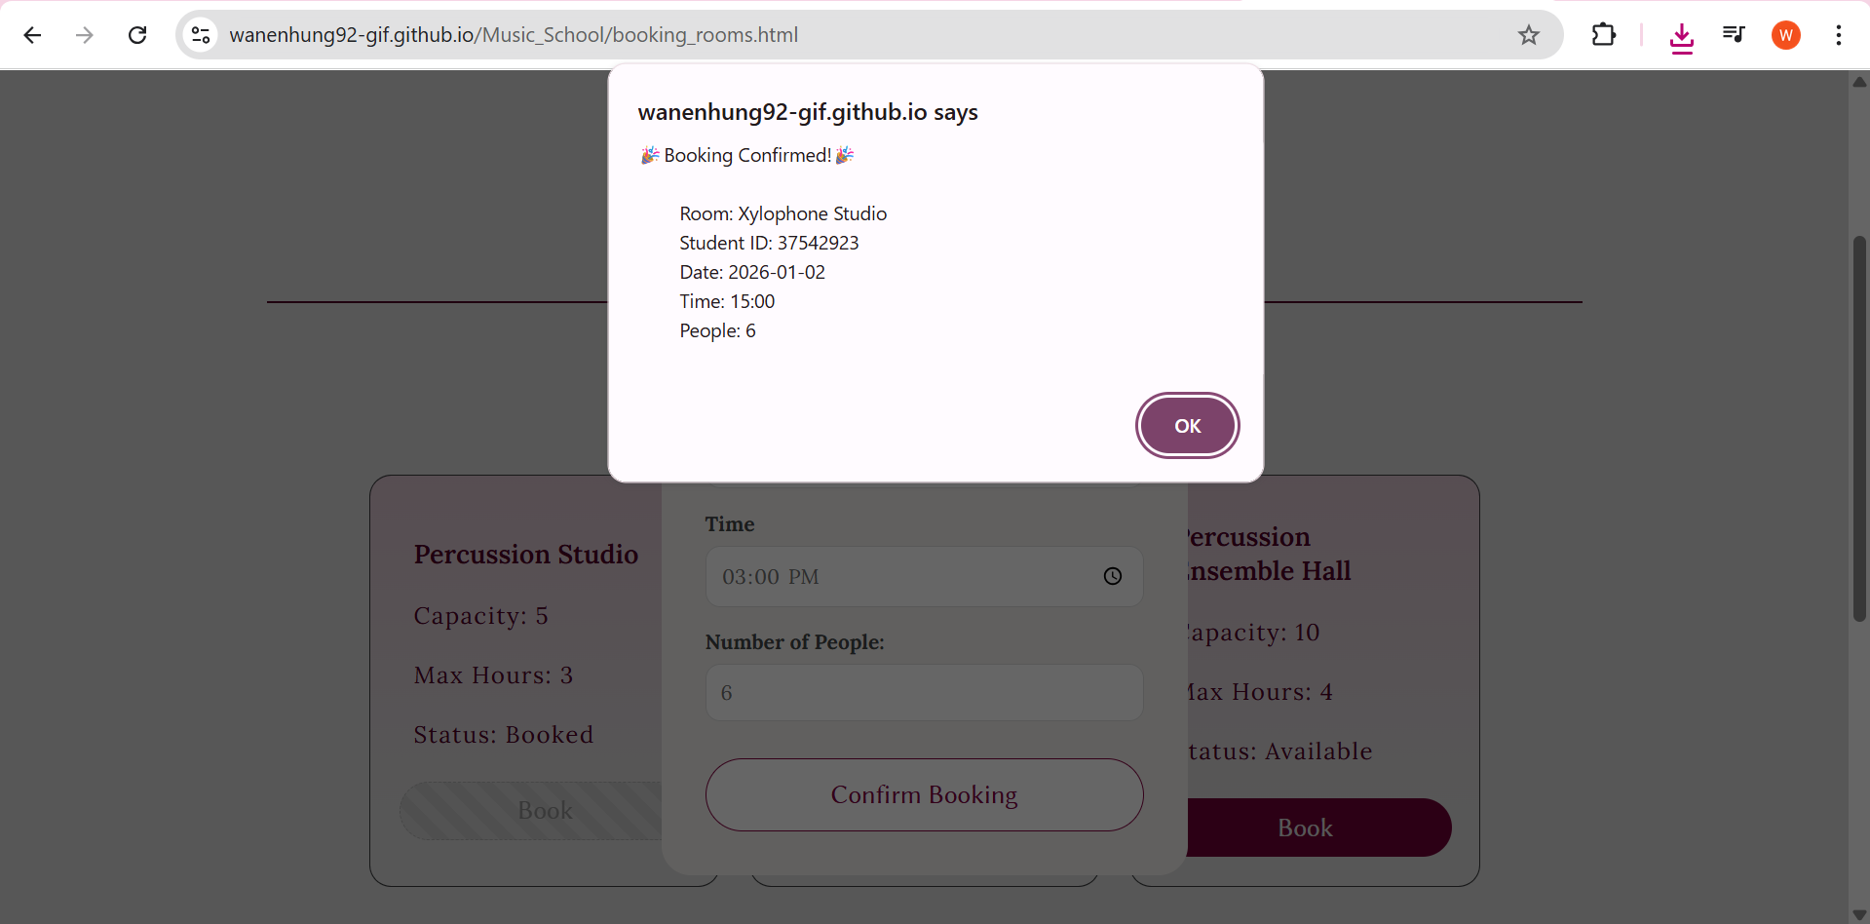

After Booking:

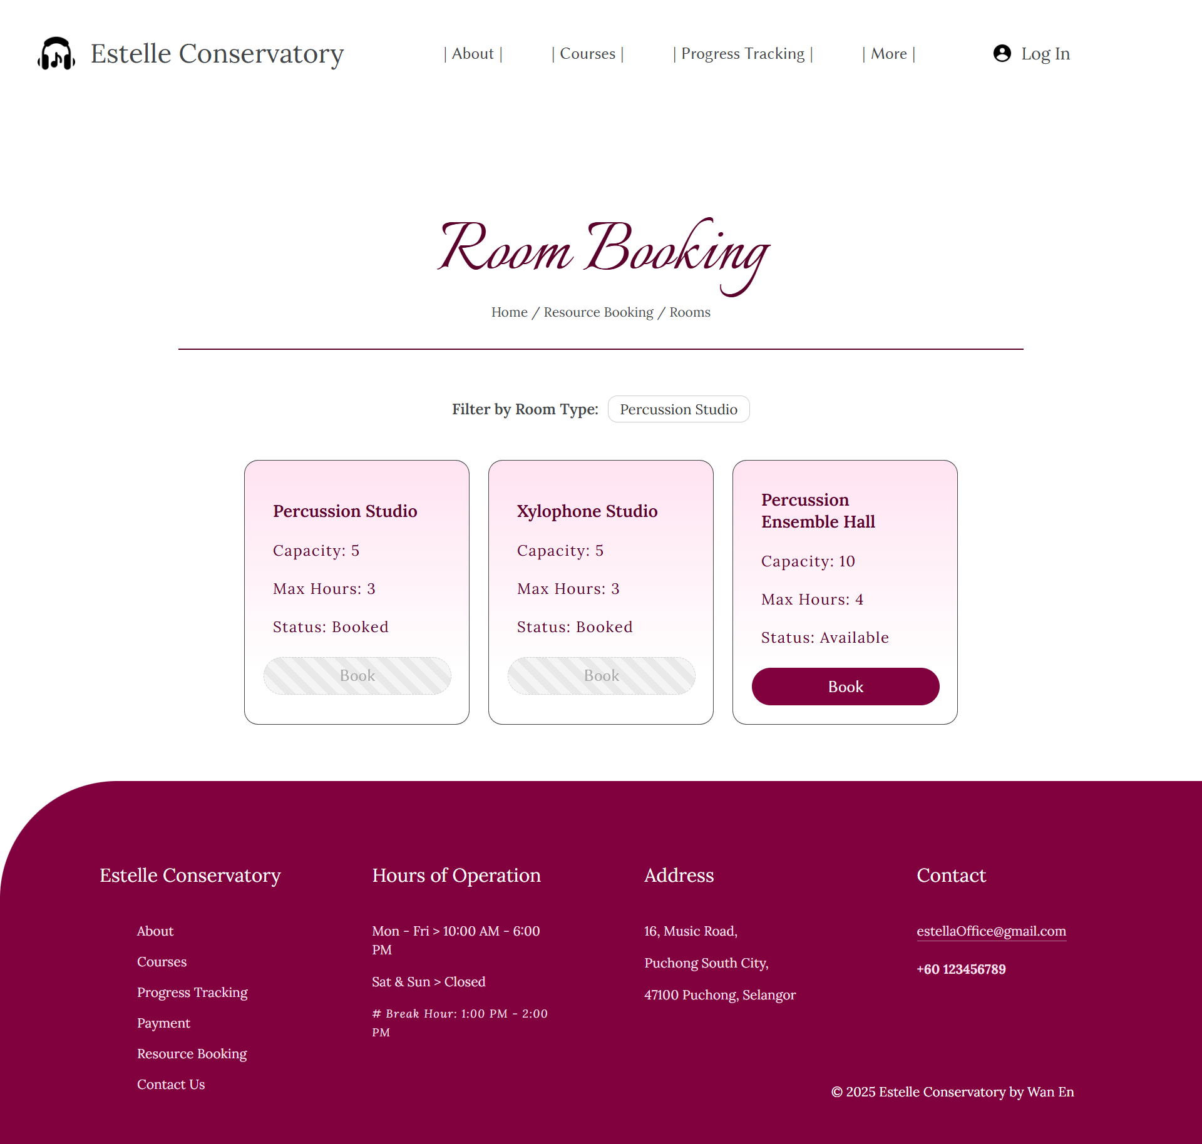

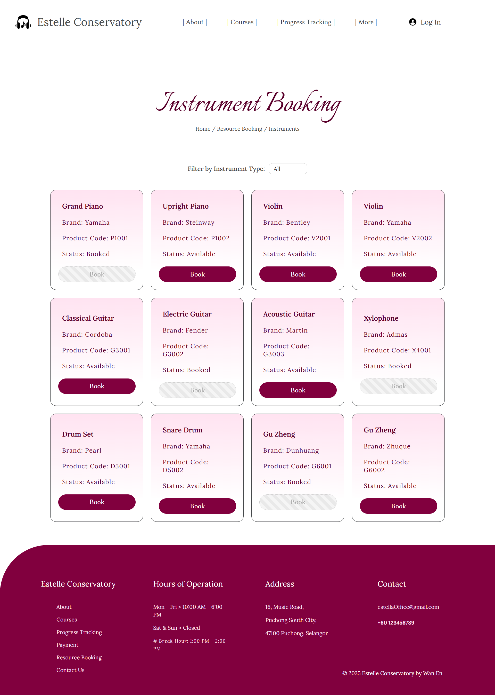

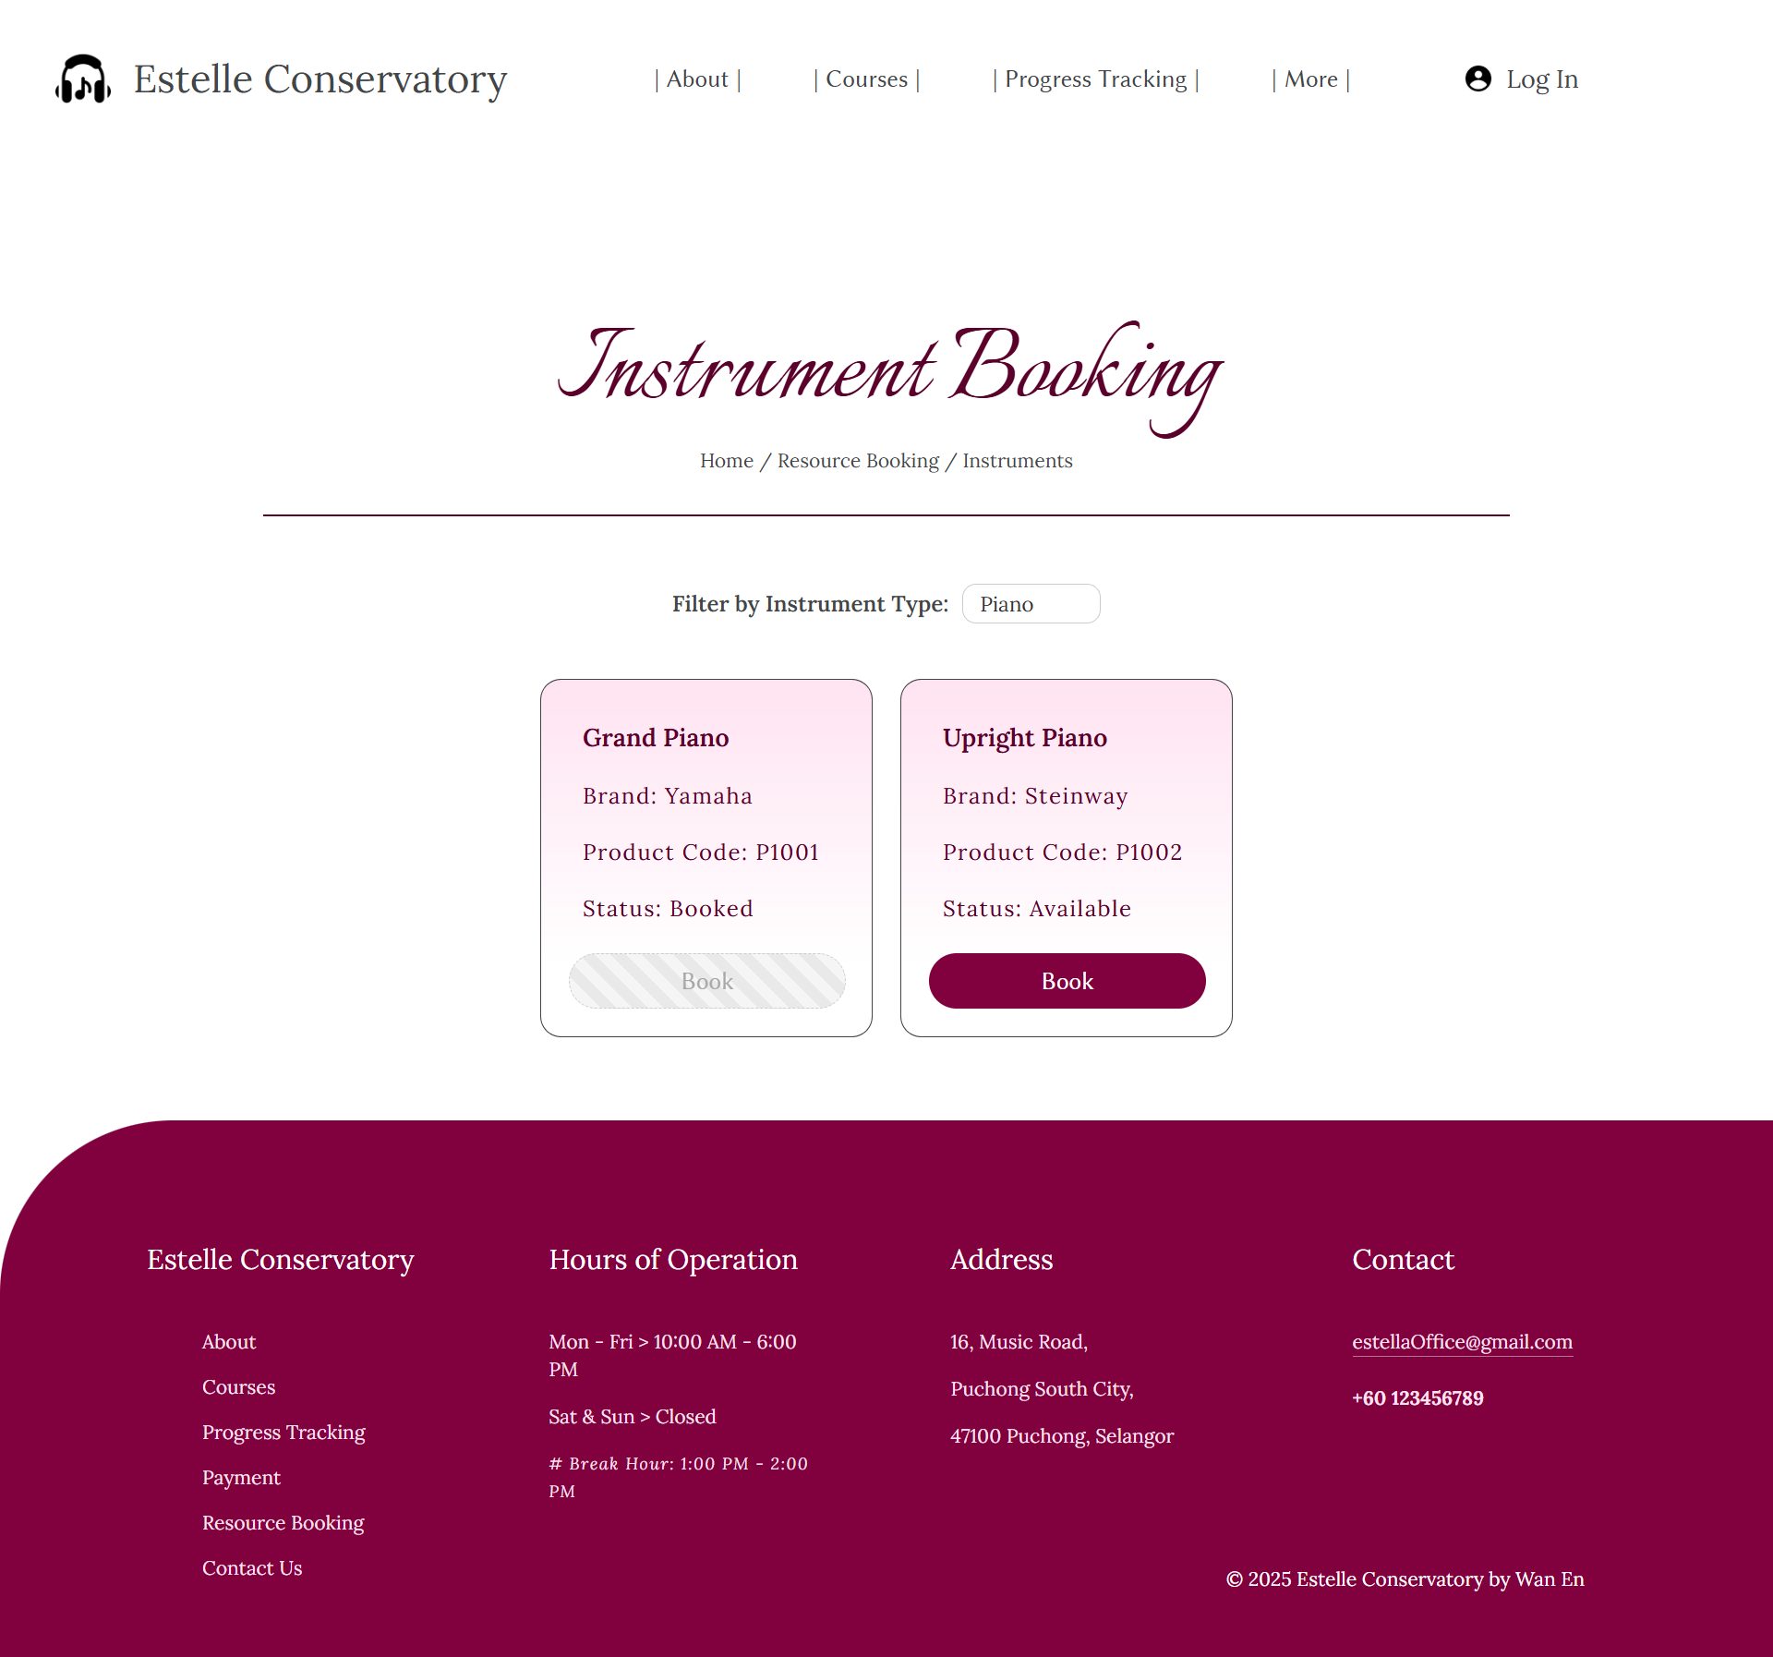



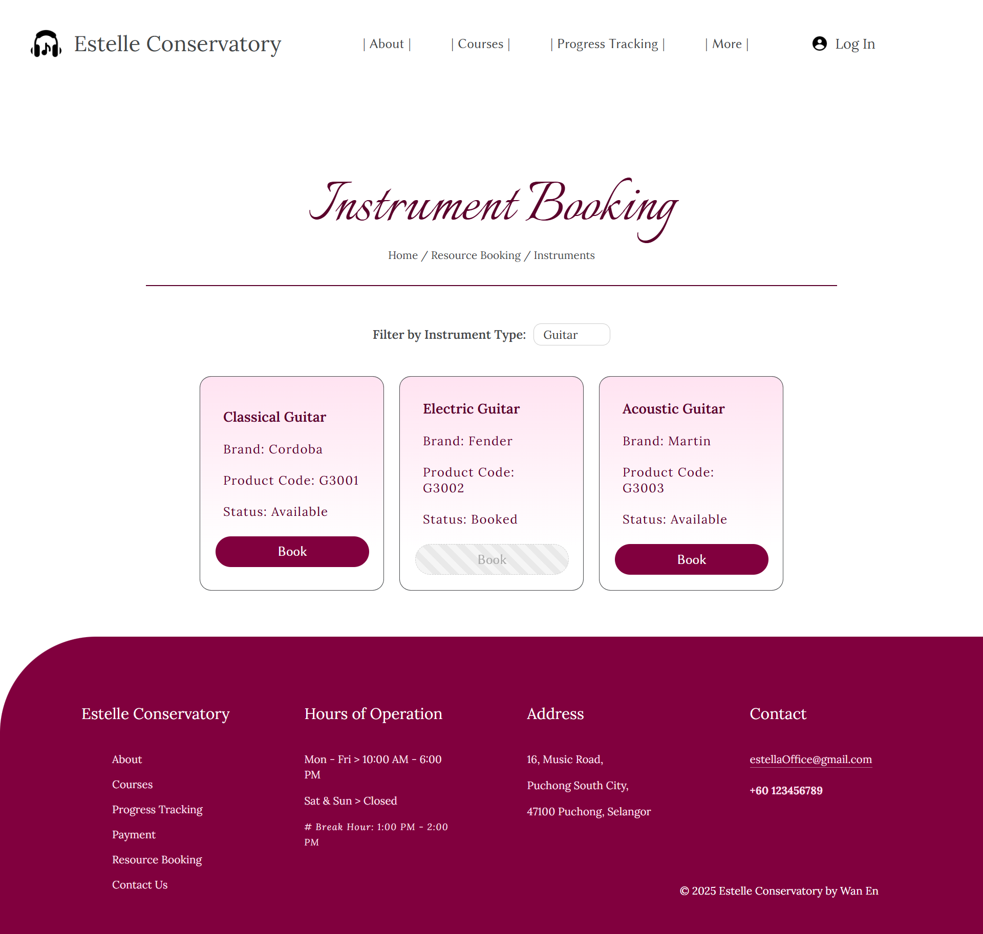

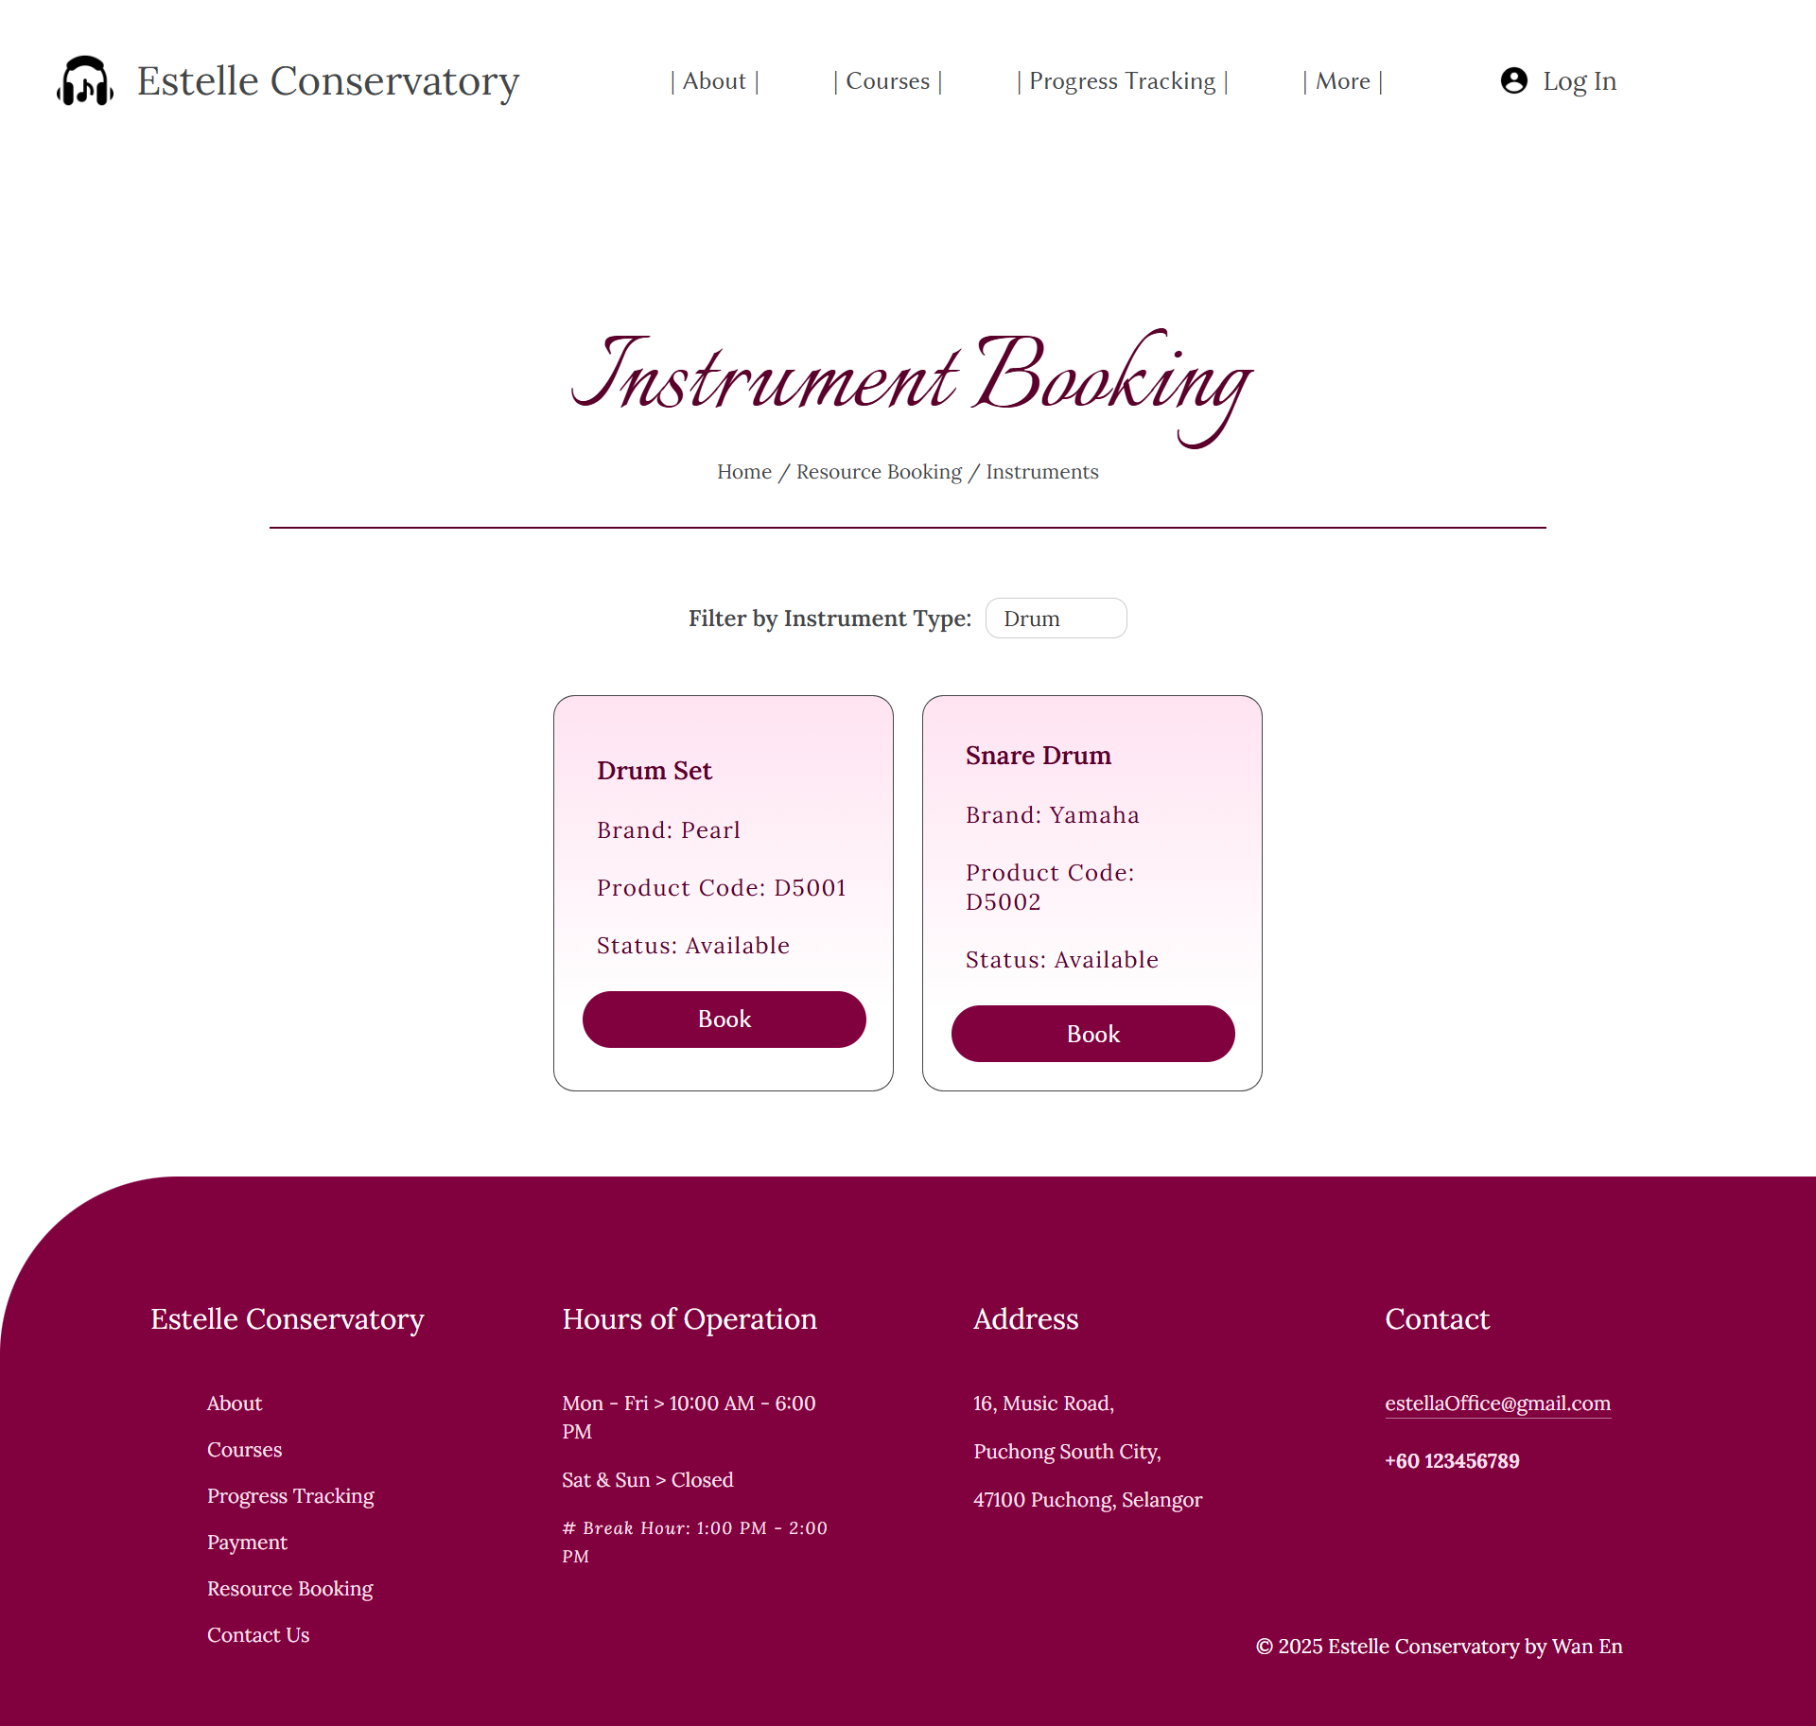

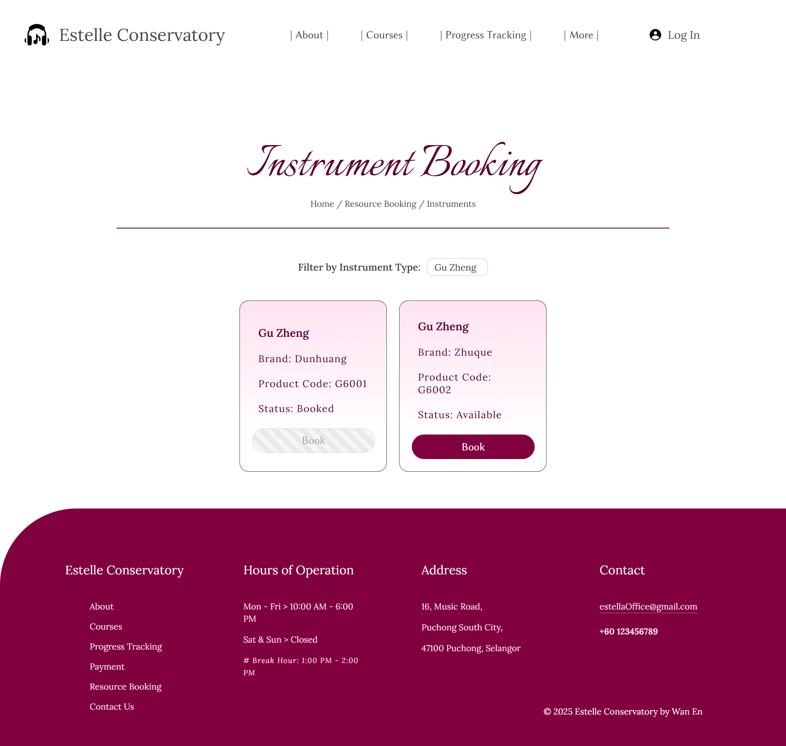

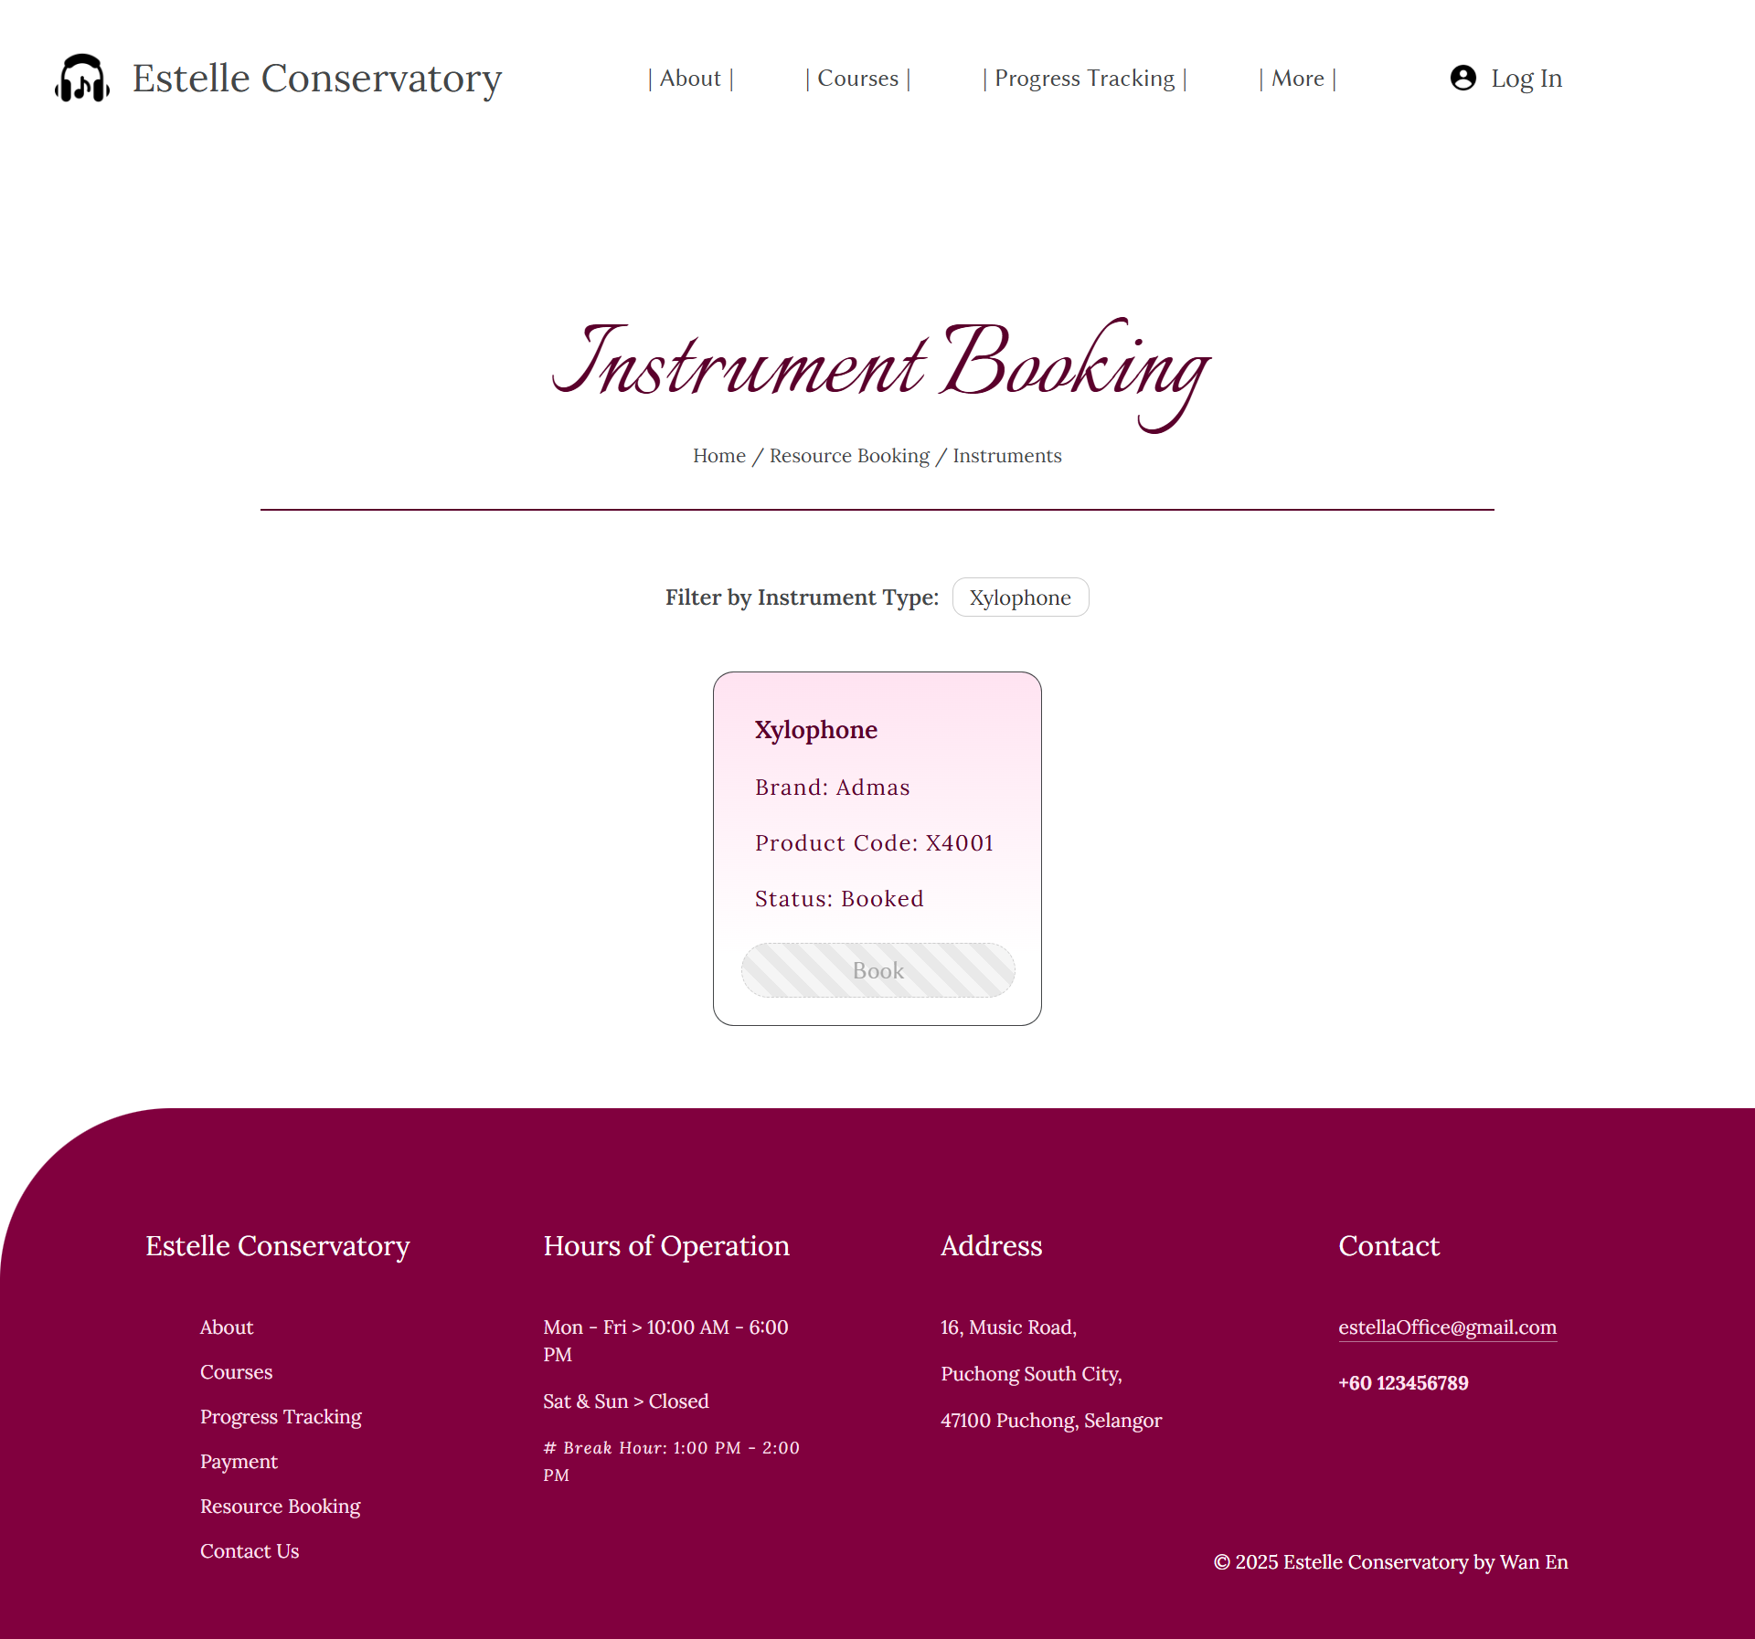

Contact:











If submit nothing:

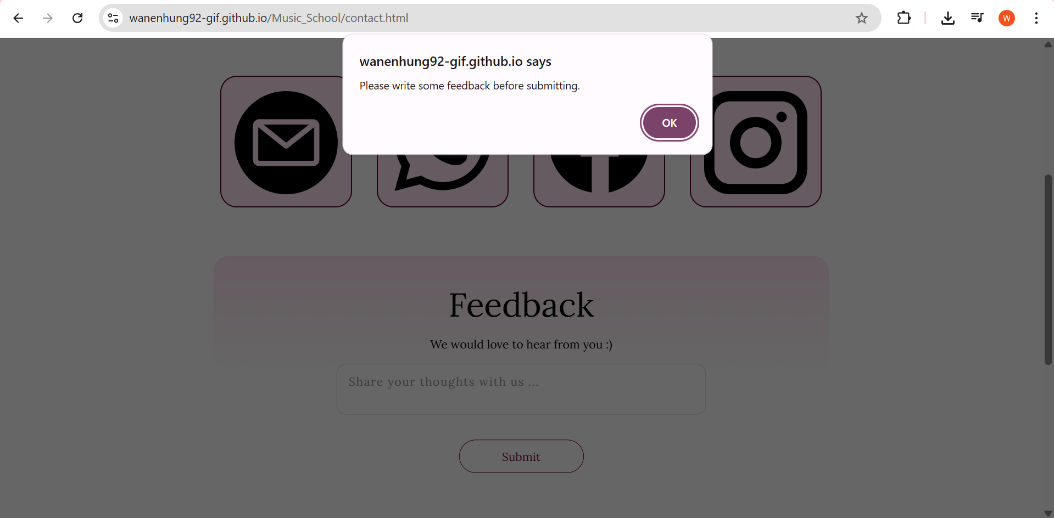

If submit:

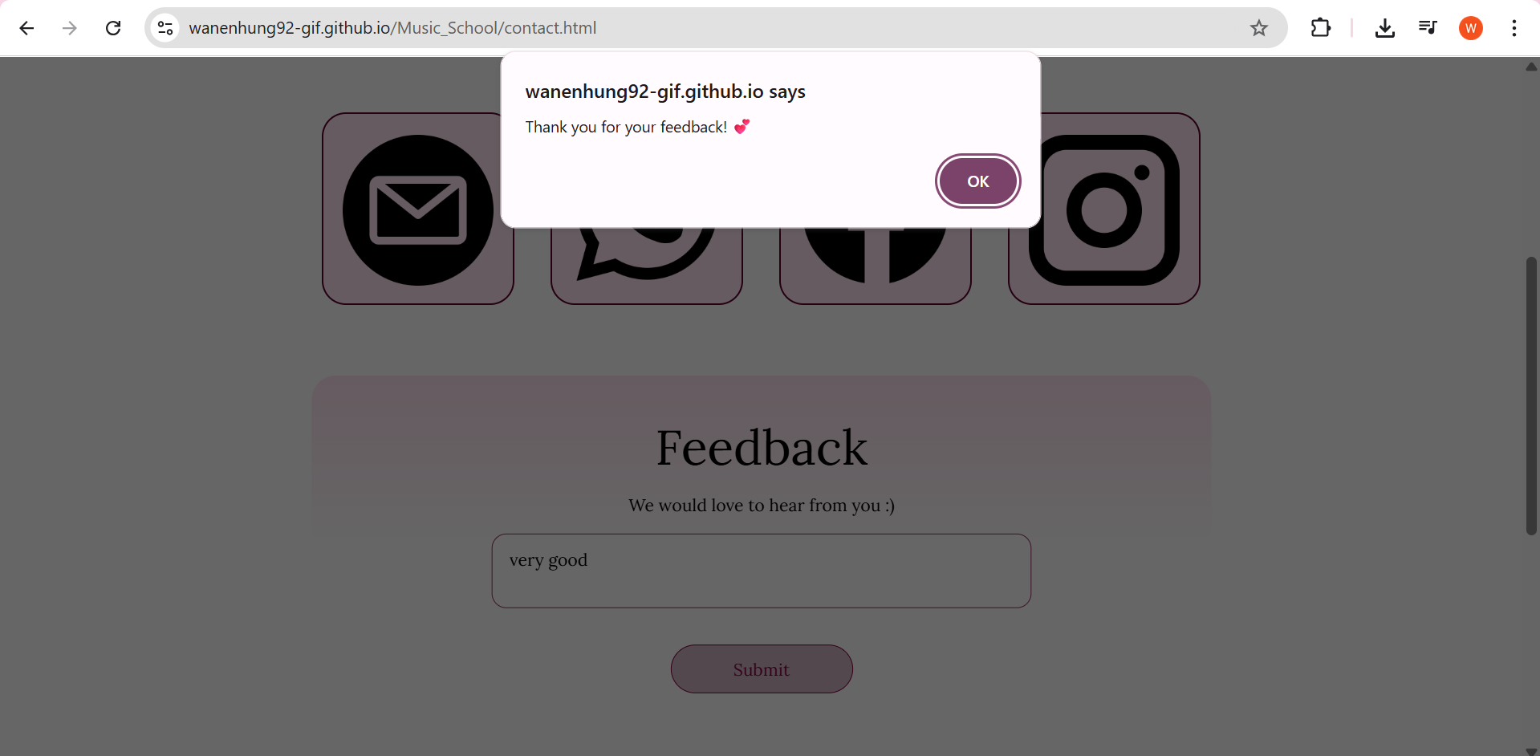

Log in:

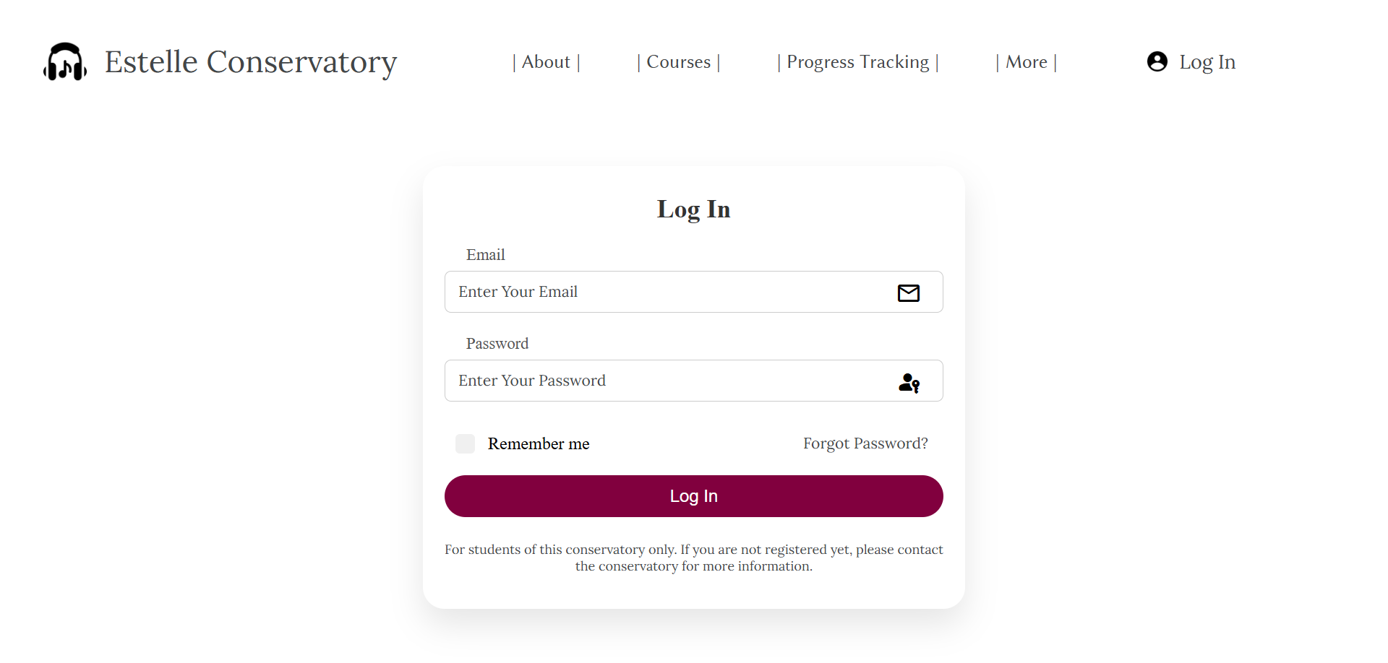

– Screenshot – 1180px × 692px –

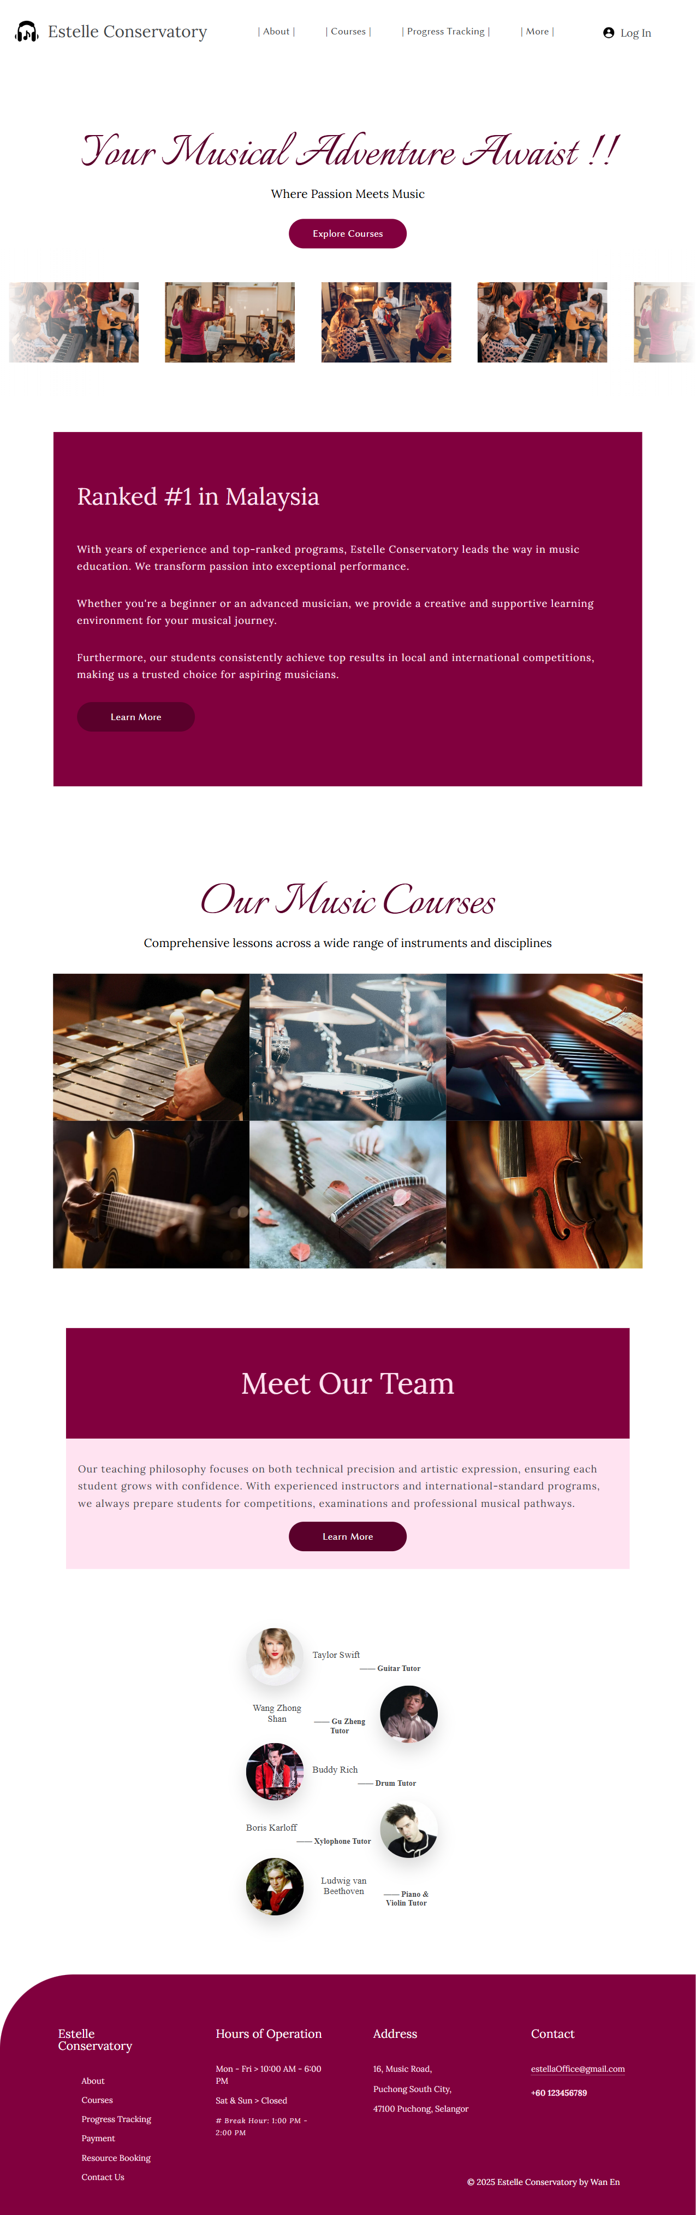



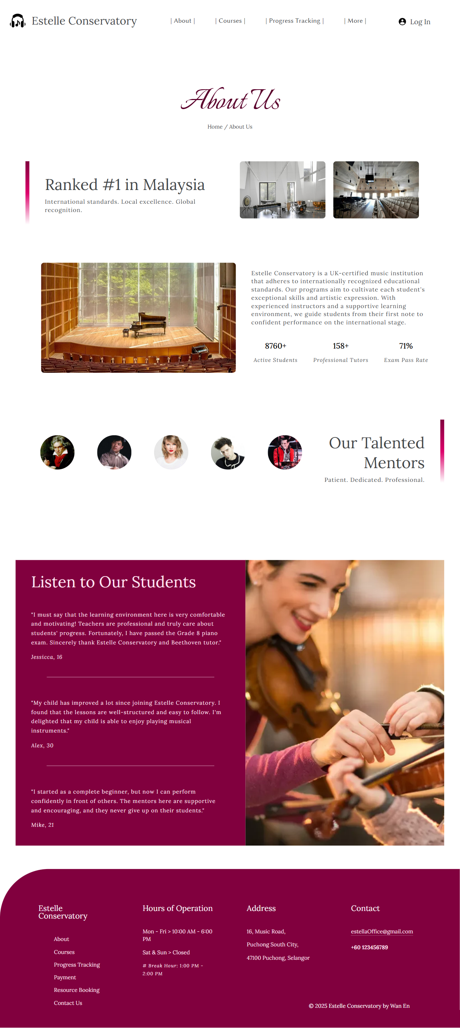





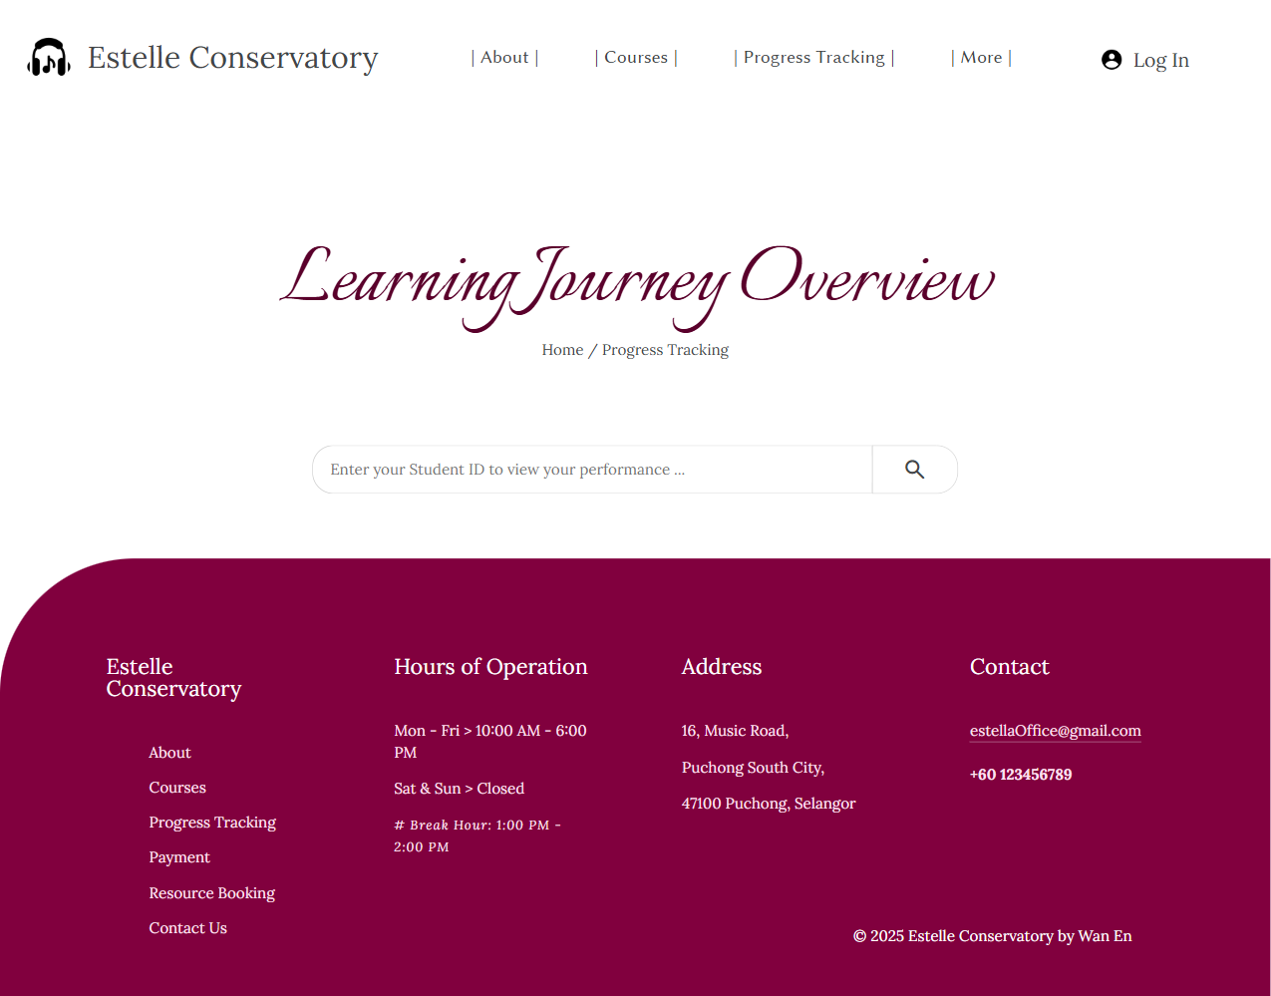

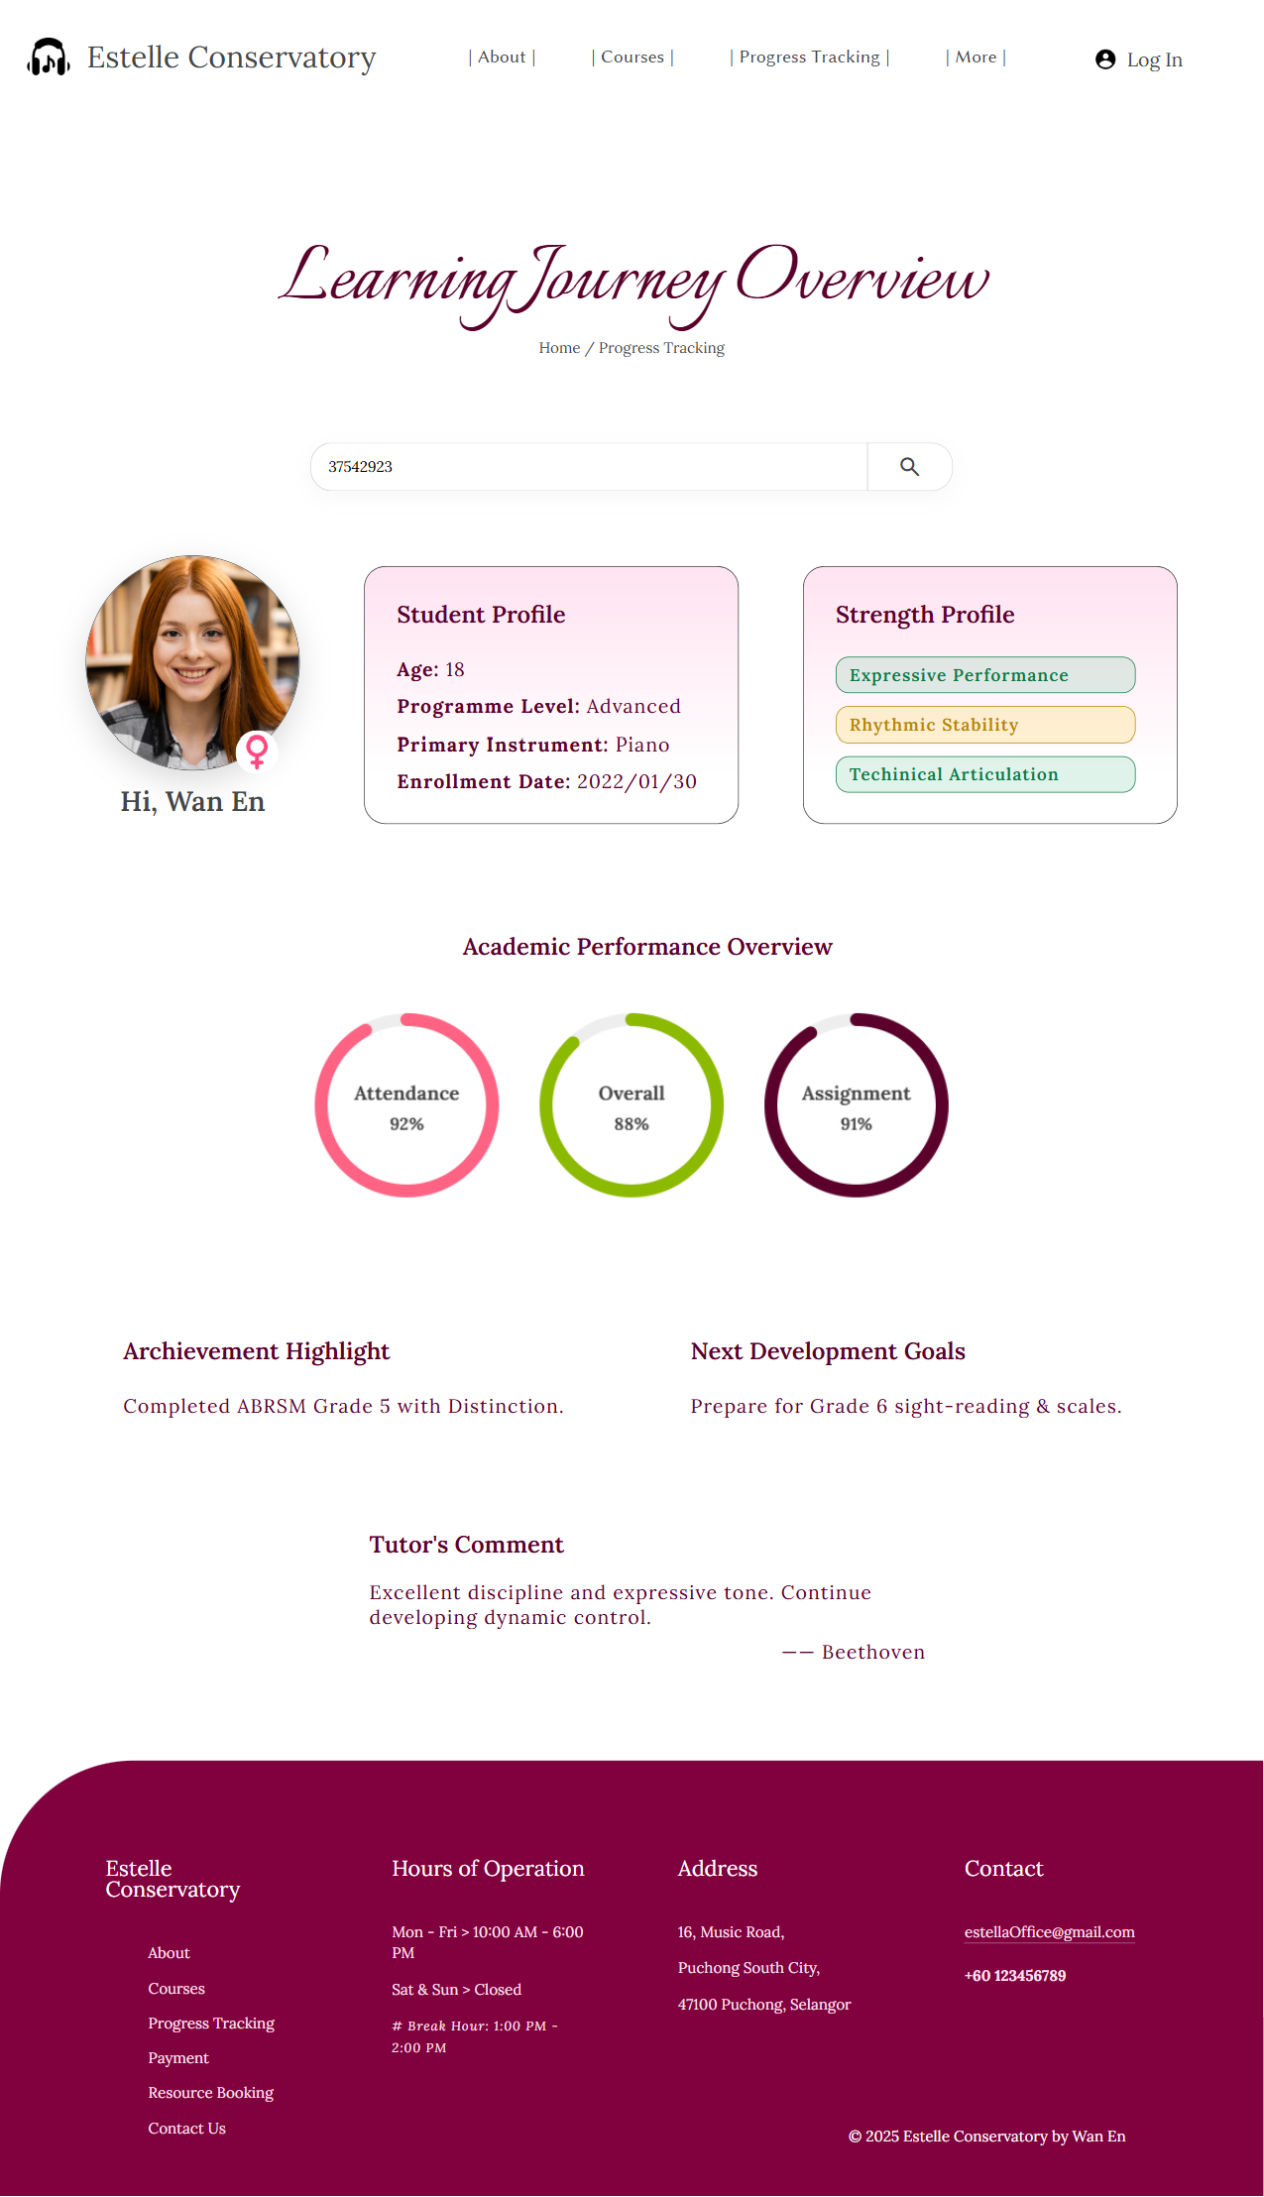

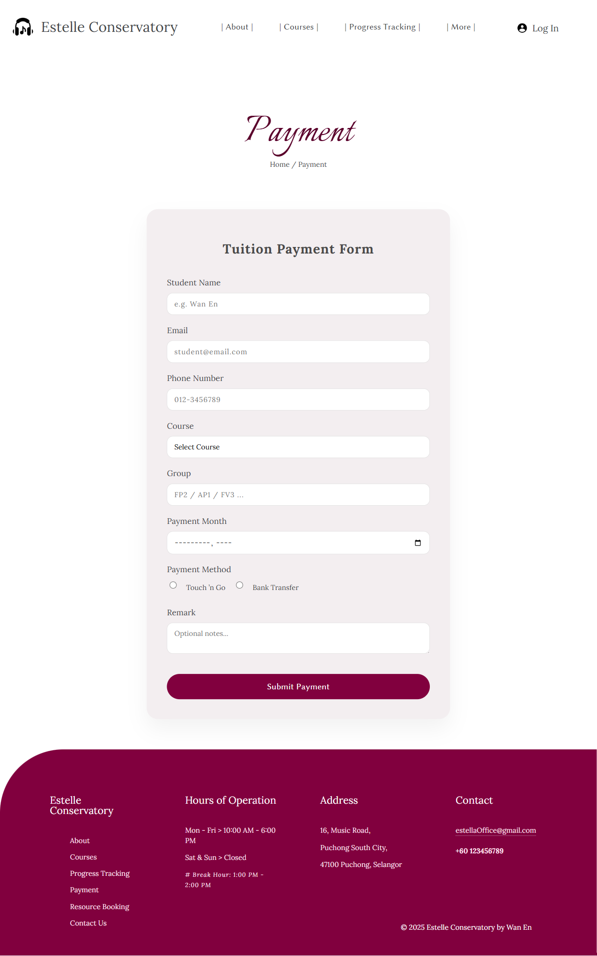

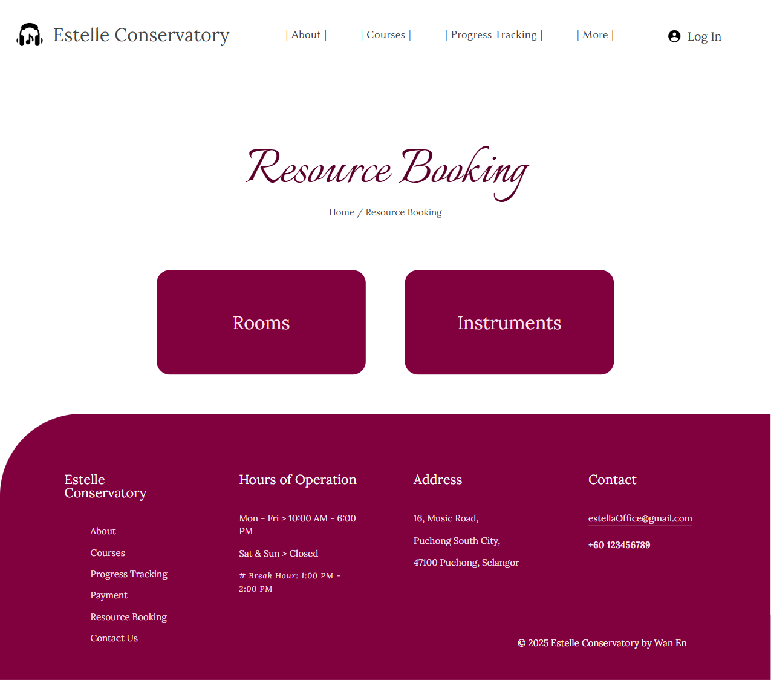

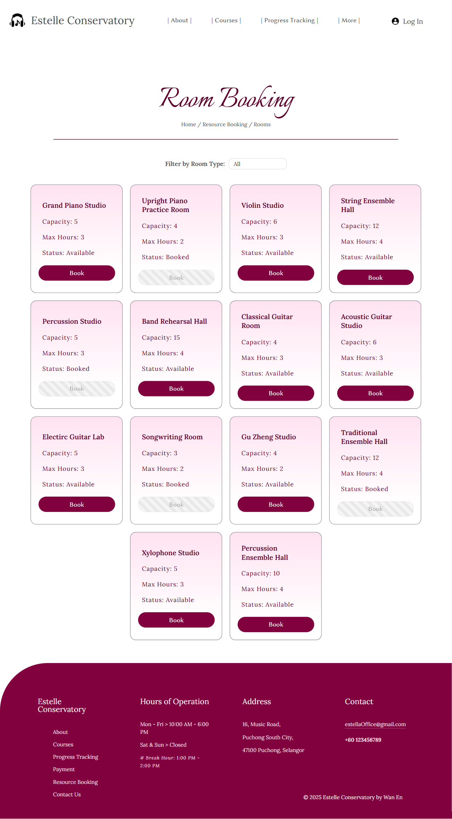

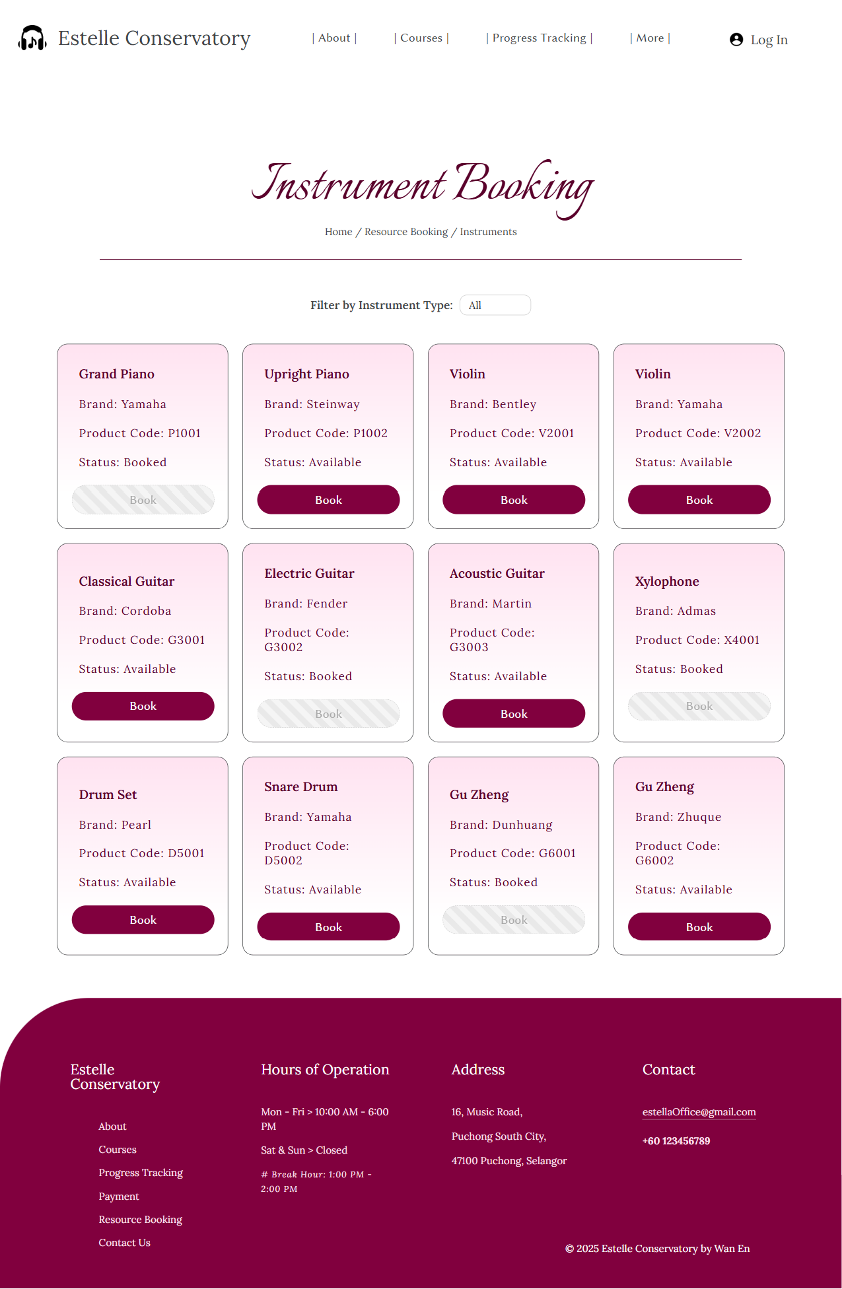

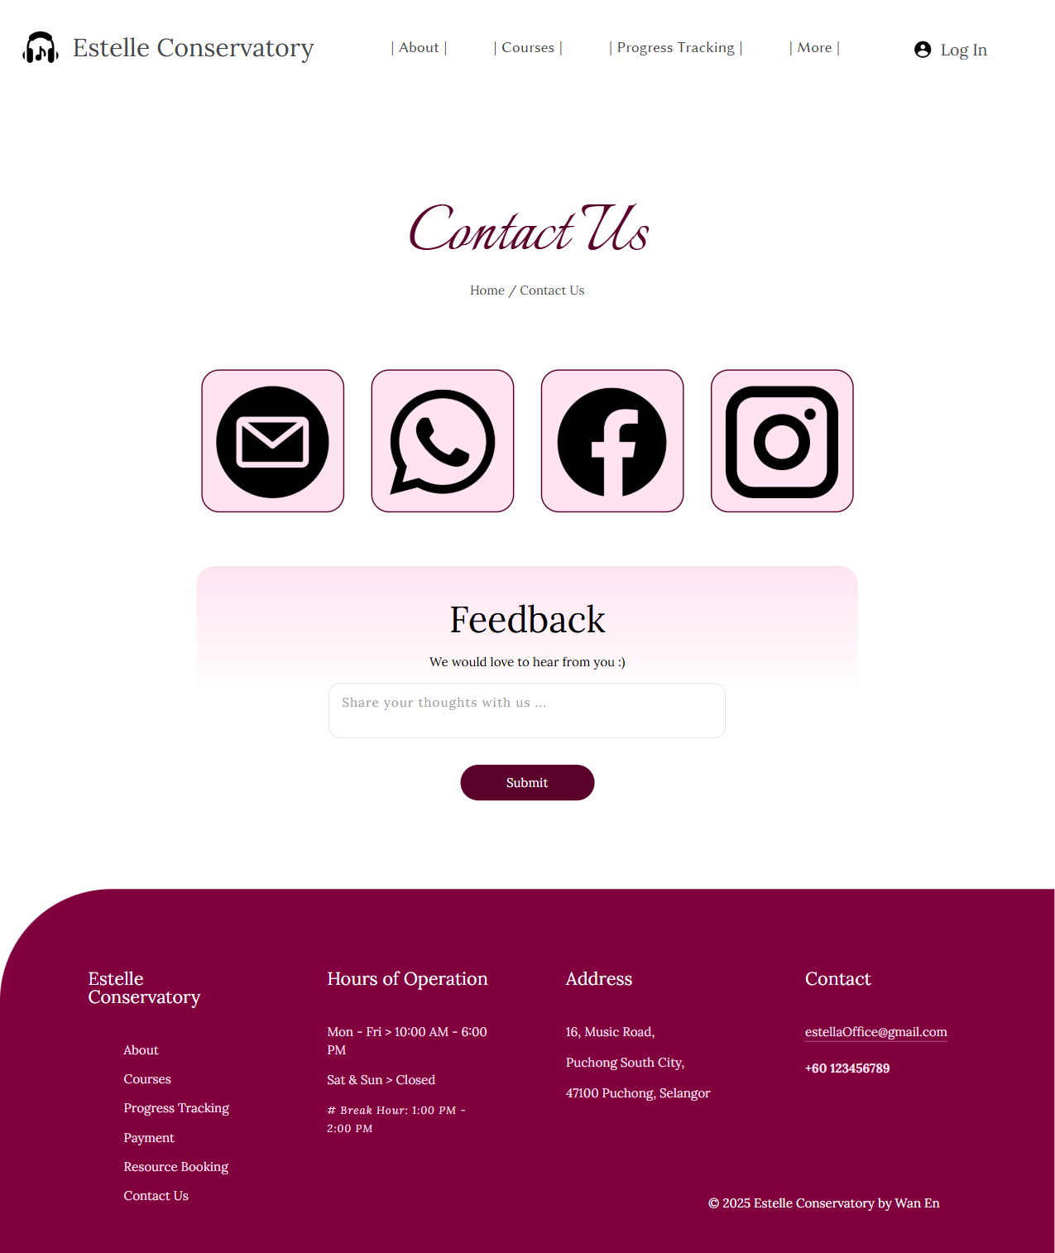

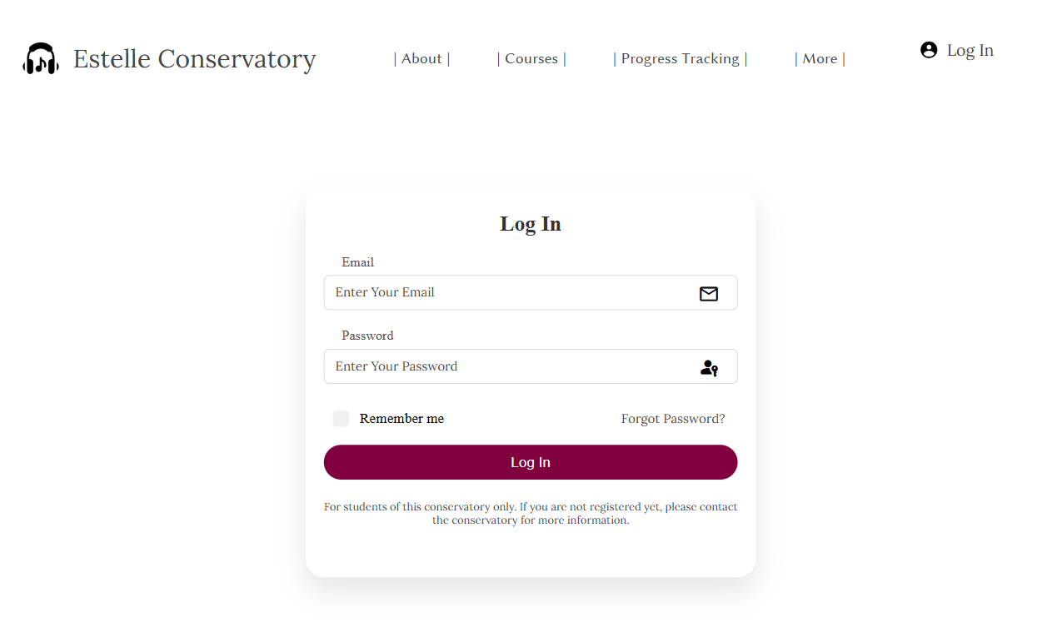

– Screenshot – 820px × 1052px –

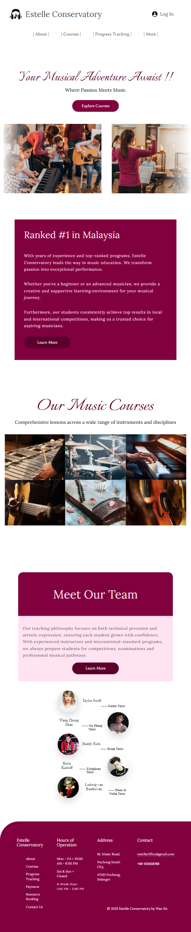



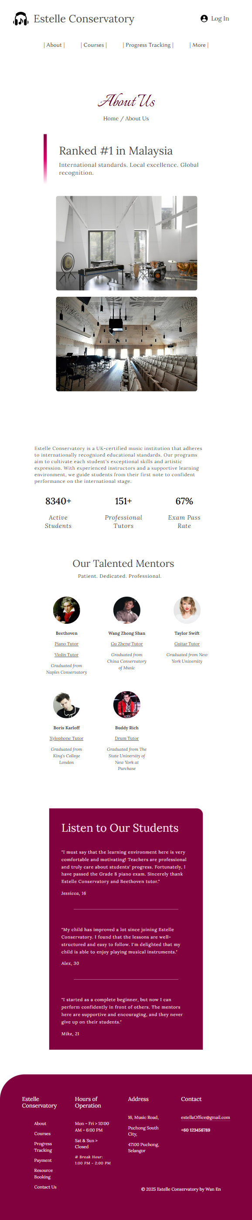



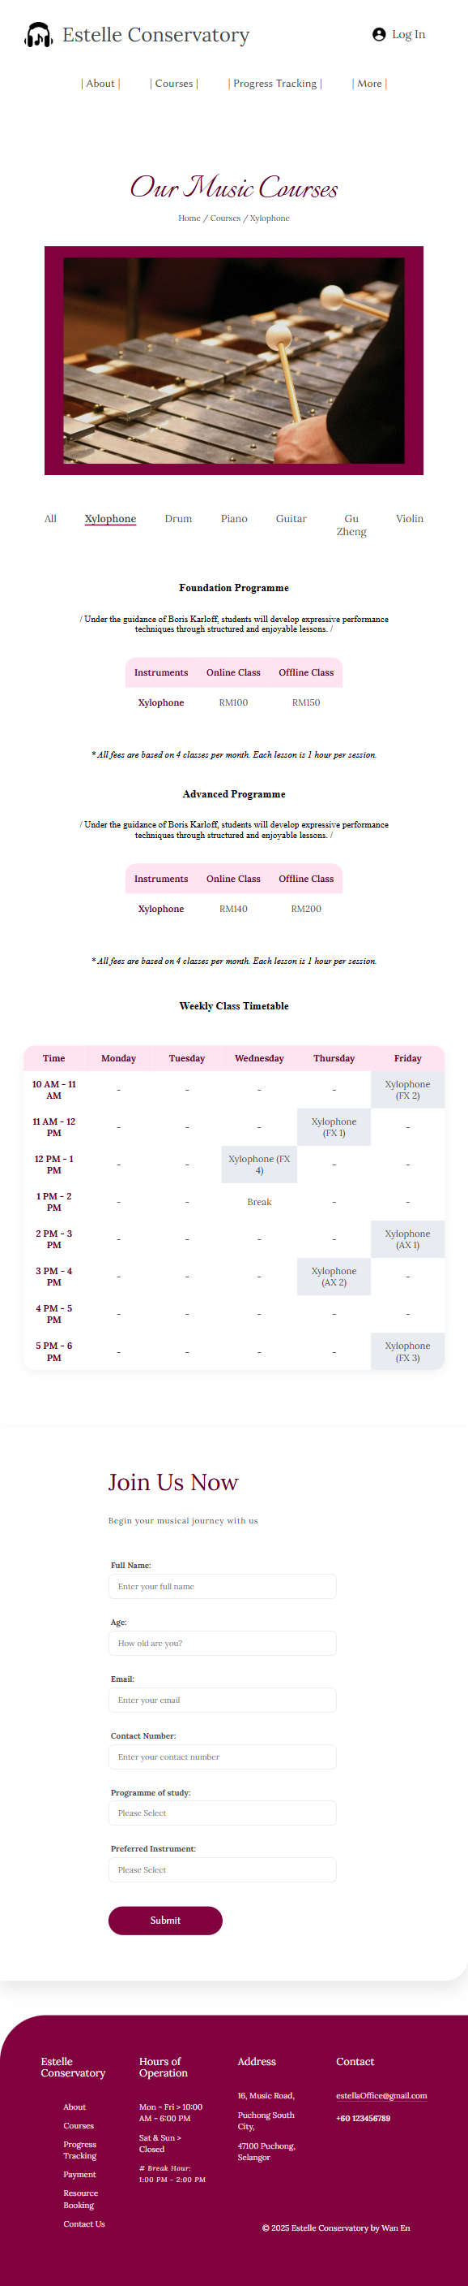

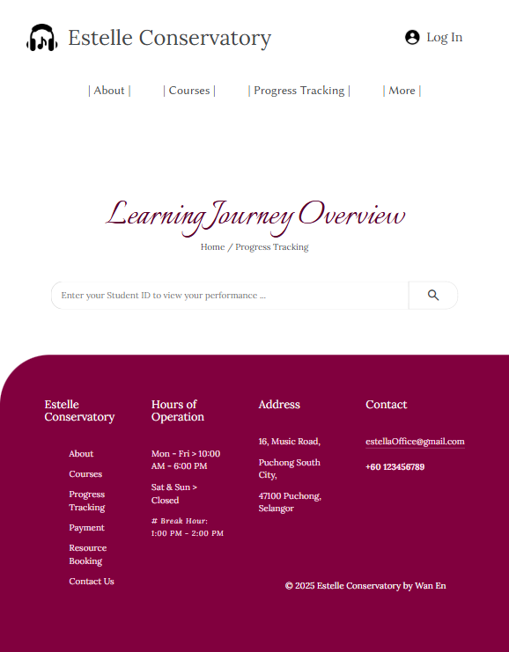

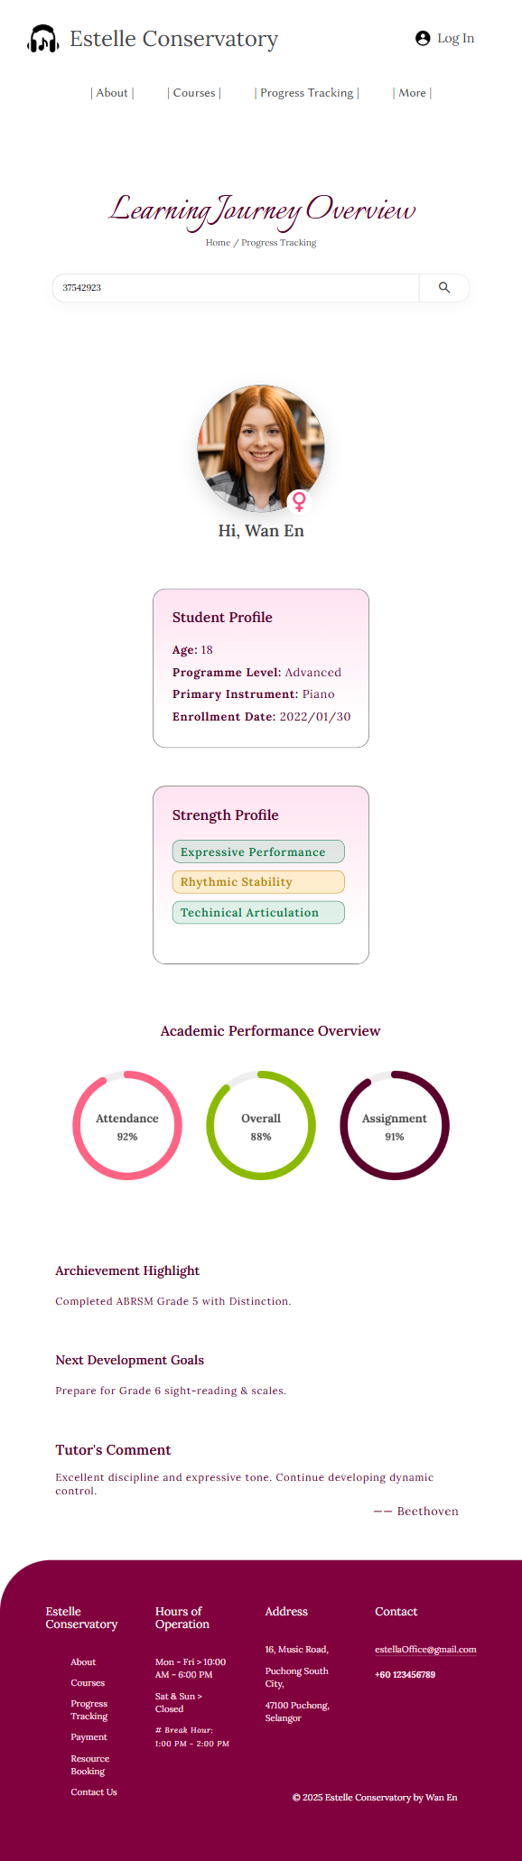

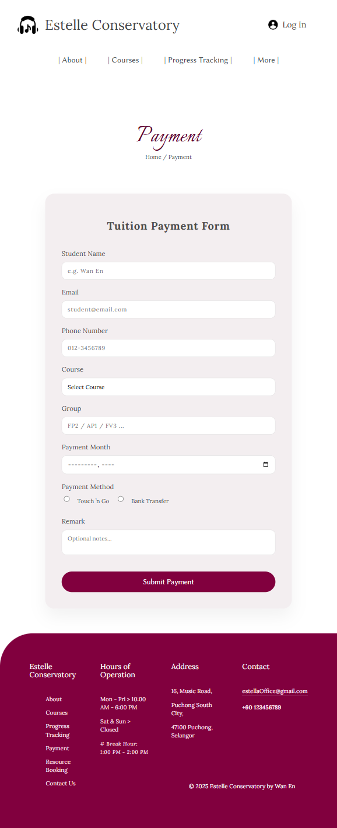

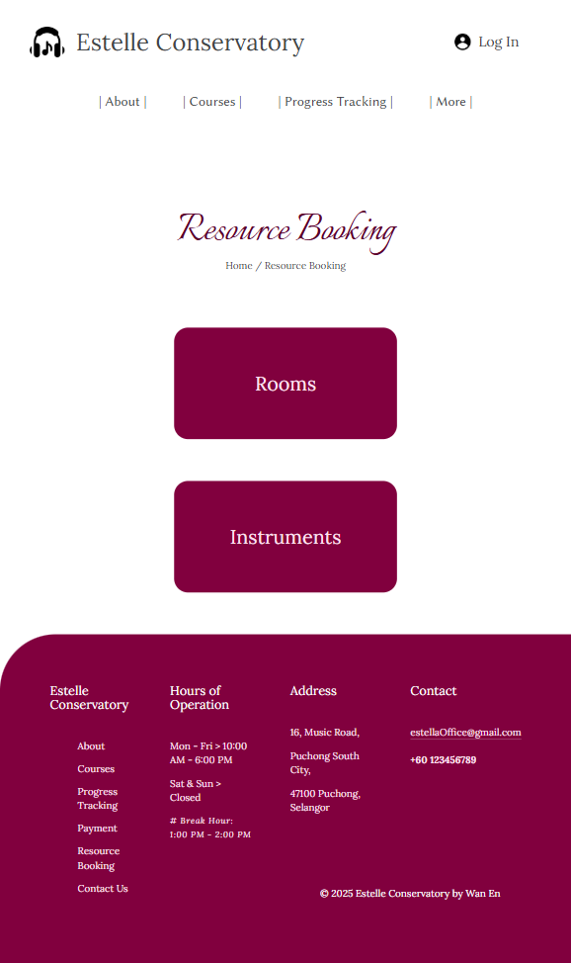

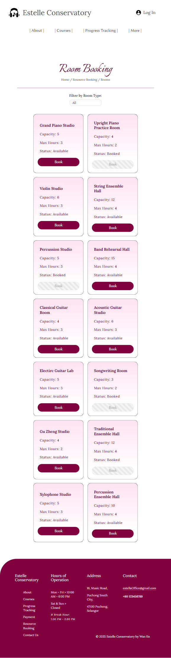



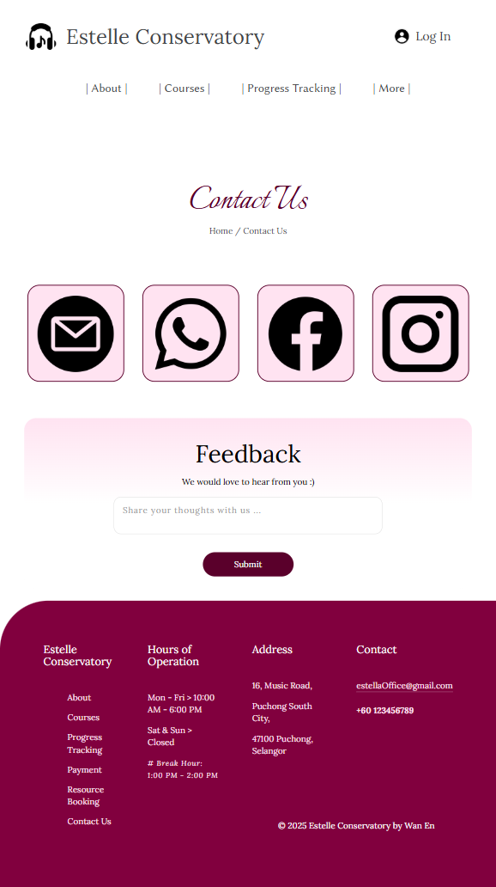

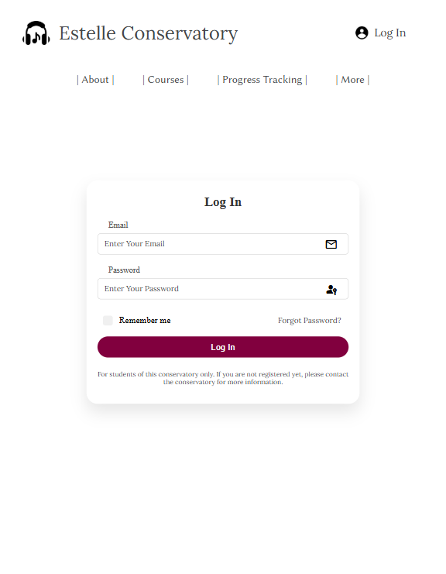

– Screenshot – 393px × 692px –





















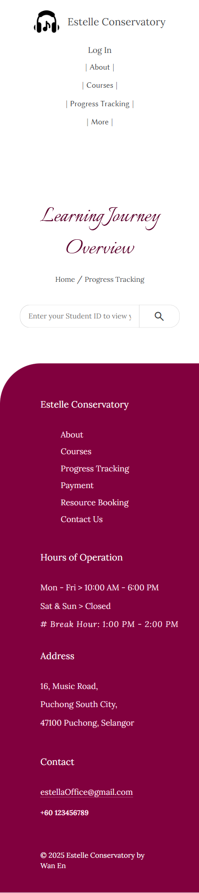



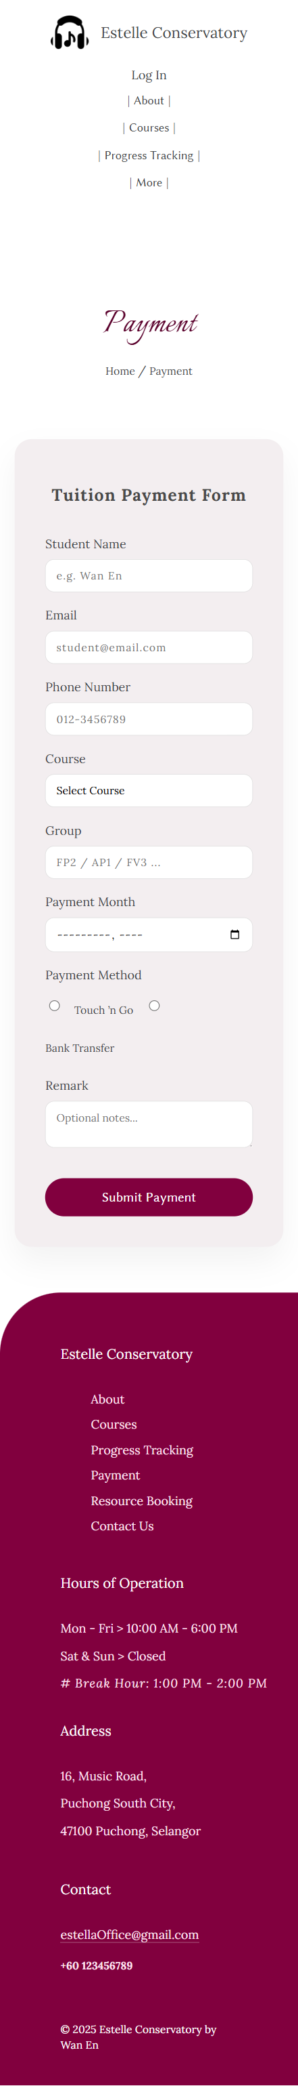

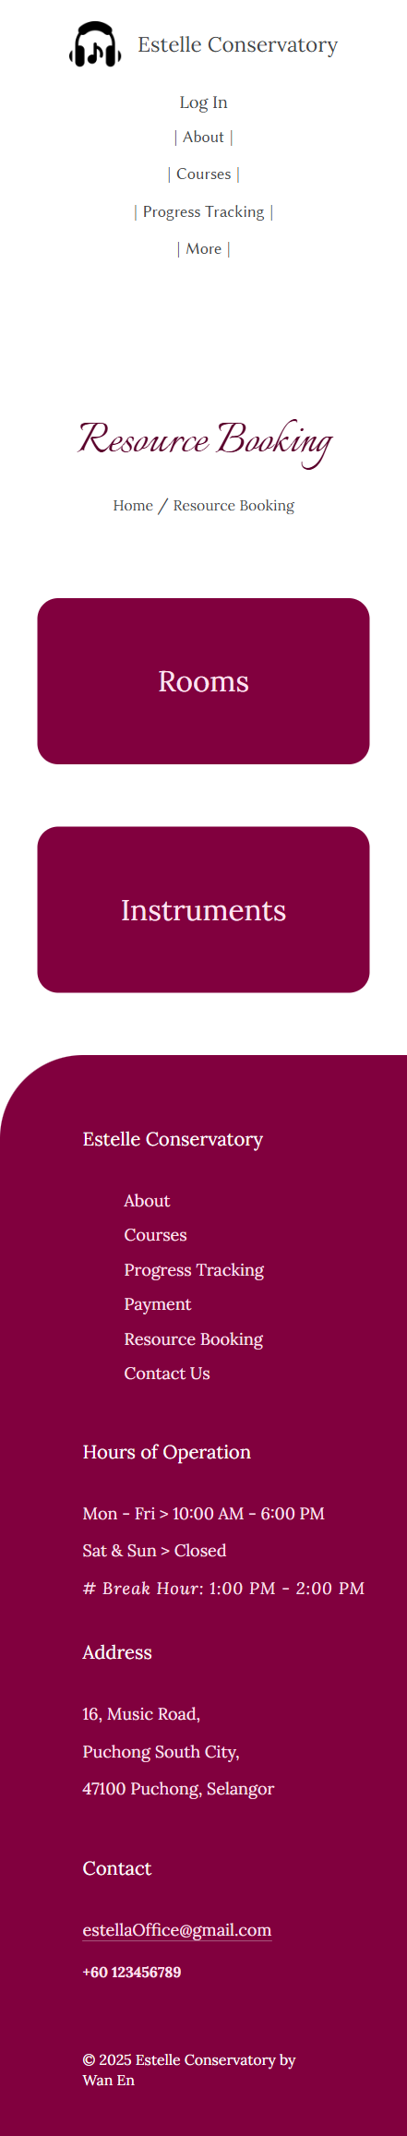





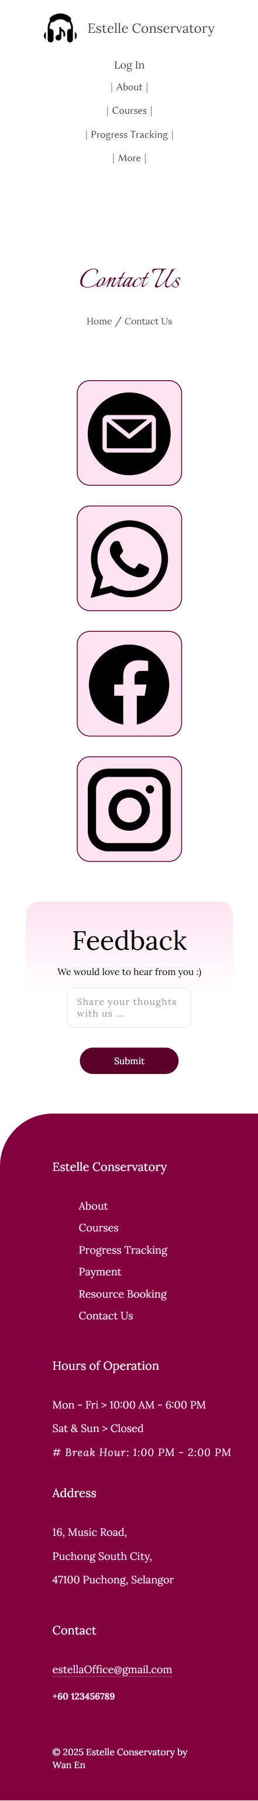

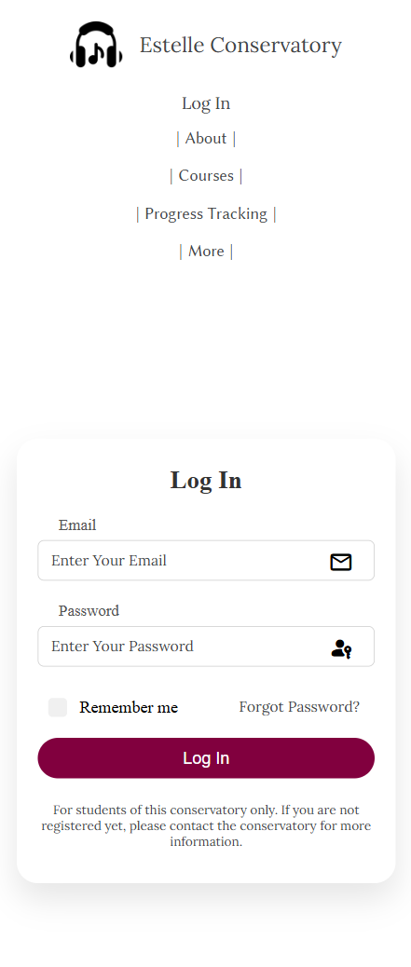

– Reference –

*image*

**Index**

Icon:

<https://cdn-icons-png.flaticon.com/512/12331/12331305.png>

Estelle Conservatory’s Logo:

<https://cdn-icons-png.flaticon.com/512/1014/1014333.png>

Log-In Icon:

<https://pic.onlinewebfonts.com/thumbnails/icons_411076.svg>

Slider (Cover 1):

<https://www.learningspacesolutions.com/wp-content/uploads/2024/07/how-music-education-has-changed-impact-on-learning-space-design.jpg>

Slider (Cover 2):

<https://media.istockphoto.com/id/1172436136/photo/children-orchestra-in-music-school.jpg?s=170667a&w=0&k=20&c=uahbJf6_1tzuTDwm2myFaZGxif3UEVSwZlEUqnDU758=>

Slider (Cover 3):

<https://thesoundartist.com/cdn/shop/articles/top-benefits-of-music-lessons-for-youth-and-adults-599653.png?v=1753478370>

Ranked#1:

<https://mississaugapianostudios.com/wp-content/uploads/2021/10/music-lessons.png>

Courses (Drum):

<https://images.unsplash.com/photo-1524230659092-07f99a75c013?fm=jpg&q=60&w=3000&ixlib=rb-4.1.0&ixid=M3wxMjA3fDB8MHxwaG90by1wYWdlfHx8fGVufDB8fHx8fA%3D%3D>

Courses (Piano):

<https://blogcasio.com.br/wp-content/uploads/2024/04/2-1024x576.jpg>

Courses (Xylophone):

<https://wallpapercat.com/w/full/0/6/1/1168824-2048x3072-samsung-hd-xylophone-wallpaper-image.jpg>

Courses (Violin):

<https://www.wfmt.com/wp-content/uploads/2024/03/iStock-1270059124_fiddle.jpg>

Courses (Guitar):

<https://www.musicianwave.com/wp-content/uploads/2021/12/Easiest-Guitar-for-Beginners-788x525.jpg>

Courses (Guzheng):

<https://wy-static.wenxiaobai.com/aigc-online/delogo_bcee0636-d8fe-4af7-a5d8-a777fe34b437.webp?ratioWH=1.4933920704845816&type=opt>

Team (Beethoven):

<https://5b0988e595225.cdn.sohucs.com/q_70,c_zoom,w_640/images/20171029/c6ce73a2d7234365befb1c9a01ee1db8.jpeg>

Team (Wang Zhong Shan):

<https://photocdn.sohu.com/20100223/Img270380645.jpg>

Team (Karloff):

<http://www.mt77.com/yyrl/yyrl-6/aef_hero_edu_doug_goodkin.jpg>

Team (Buddy Rich): <https://d10j3mvrs1suex.cloudfront.net/s:bzglfiles/u/556602/d6bb29ece24bafd97ccf7dadb10b4156ceacbae1/original/buddy-rich-big-band-machine-5765.jpg/!!/b%3AW1sicmVzaXplIiwxODAwXSxbIm1heCJdLFsid2UiXV0%3D/meta%3AeyJzcmNCdWNrZXQiOiJiemdsZmlsZXMifQ%3D%3D.jpg>

Team (Taylor Swift):

<https://images.universal-music.de/img/assets/351/351514/992/1200/taylor-swift-2014.jpg>

**About**

Conservatory1:

<https://arqa.com/wp-content/uploads/2020/05/ofis_kgbl_photo@tomaz-gregoric_23.jpg>

Conservatory2:

<https://encrypted-tbn0.gstatic.com/images?q=tbn:ANd9GcT2TptYVobRiGlaebGA_PYTgmR7_ZboeUGi0RDLKzRCSo317t9M>

Conservatory3:

<https://static.dezeen.com/uploads/2014/06/Aix-en-Provence-Conservatory-of-Music-by-Kengo-Kuma_dezeen_468_1.jpg>

Listen (Cover4):

<https://www.evanvandoren.com/wp-content/uploads/2023/09/Untitled-design-1-1080x630.webp>

**Courses**

Office: <https://www.ul.com/sites/default/files/styles/hero_boxed_width/public/2023-05/GettyImages-1329940971-living-walls-in-modern-office-HEADER-2400x1600.jpg?itok=5jMWZznk>

**Progress Tracking**

Female Icon:

<https://img.freepik.com/premium-vector/pink-gender-symbol-female_277625-1824.jpg?semt=ais_hybrid&w=740&q=80>

Male Icon:

<https://cdn-icons-png.freepik.com/256/7302/7302735.png?semt=ais_white_label>

Wan En:

<https://img.freepik.com/free-photo/close-up-beautiful-woman-smiling_23-2148369437.jpg>

Jack:

<https://img.freepik.com/free-photo/portrait-delighted-hipster-male-student-with-crisp-hair_176532-8157.jpg?semt=ais_hybrid&w=740&q=80>

Emily:

<https://kpopping.com/documents/b2/5/800/Emily-The-Debut-Dream-Academy-Profile-photos-documents-1.jpeg?v=5c179>

Ryan:

<https://img.freepik.com/free-photo/medium-shot-cute-modern-boy_23-2148423127.jpg?semt=ais_hybrid&w=740&q=80>

Mei Ling:

<https://static.vecteezy.com/system/resources/previews/007/322/816/large_2x/beautiful-asian-woman-in-white-dress-happy-and-big-smile-with-natural-sunlight-in-the-park-thai-girl-or-chinese-girl-enjoy-on-holiday-in-garden-free-photo.jpg>

Hafiz:

<https://media.istockphoto.com/id/1326482512/photo/man-alone-with-coffee.jpg?s=612x612&w=0&k=20&c=Wa1azsyK8ImqyLrWbvhfXavZR51d_2UqSxHLB6MpSRU=>

**Contact**

Email Icon:

<https://cdn-icons-png.flaticon.com/512/3178/3178158.png>

Facebook Icon:

<https://cdn-icons-png.flaticon.com/512/2175/2175193.png>

WhatsApp Icon:

<https://cdn-icons-png.flaticon.com/512/1384/1384023.png>

Instagram Icon: <https://cdn-icons-png.flaticon.com/512/3661/3661391.png>